Recording Concerns about a Child

Logging In

Cura is a web based application, so you will need to go your school's Cura web page on-line to log in. Someone in school (typically your network manager) will be able to give you the web page address. You will then see the Cura log in page.
If you are a SIMS user then you may be able to use your SIMS username and SIMS password. Otherwise, your username will be your work email address.
If you have not logged in before, then you will need to generate your own password. To do this, click the "Lost your password?" link at the bottom of the login page.
Enter your email address and click the "Password recovery" button. This will send an email to your email address. In the email, there will be a link that you should click. This will open another copy of Cura - you can close this new page immediately. A new password will then be emailed to you.
Depending on the settings for your account, you may also need a PIN number to login. When logging in for the first time, you may be presented with a window that says "New PIN Generation". If you see this window then your account requires a PIN number in addition to a username and password.
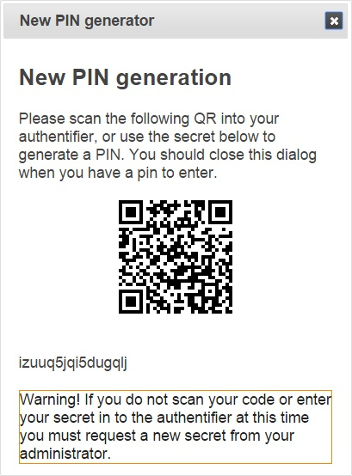
To get your PIN number you will need to download an authenticator, which is can be an app for your phone or tablet, or a program that you run on your PC. There are several different authenticators available for free via the Play Story or App Store, or search for “Windows Authenticator” if you want to run it as a program on your PC. Any of these methods will work. You should either download an authenticator immediately, or take a note of the 16 character code below the QR code.
Once you have an authenticator, scan the QR code or type in the 16 digit code to generate your PIN. Your device will generate a new PIN number every 30 seconds.

Recording a Concern

To record a concern, you first need to select the child about whom you are concerned. To do this, you will need to use the Students page.

If the page you see when you login does not look like one of the two below, click the Students button at the top left of Cura.
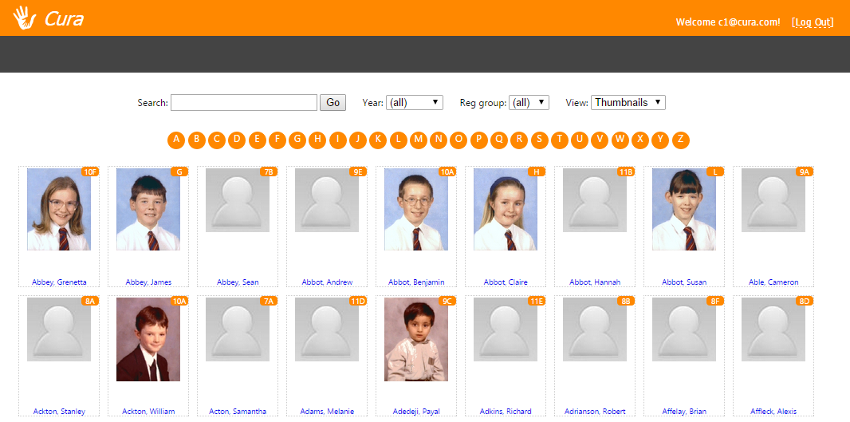

Above: the simplified view for Cura

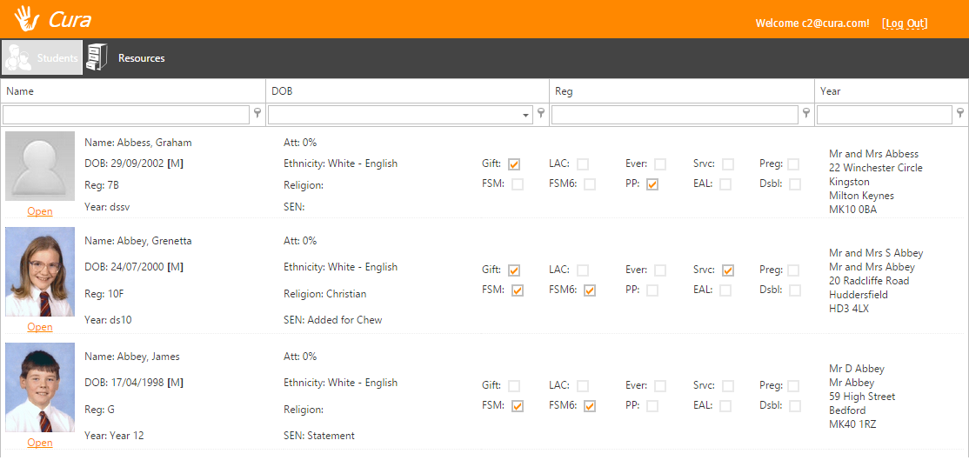

Your screen should now look like one of the two images above, depending on the permissions you have been given. Both of these screens do the same thing.

You now need to search for the pupil about whom you are concerned. You can do this using the search bar at the top to find specific pupils by name.

If you are not using the simplified view (see previous page) then you will now see the pupil’s Personal details. Click the Chronology tab at the top, and then click “New chronology entry”.

Your screen should now look like this:

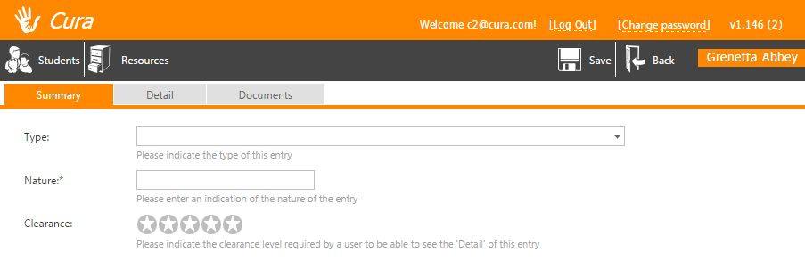

Click the Type dropdown and select “Concern”. You should then enter a brief description of the concern into the Nature field. This will be visible to all users so you should not be very specific – something like “Bruise” or “Disclosure” would be suitable.

Next choose the clearance level by clicking on one of the stars. The clearance level is used to denote how sensitive you think the concern is, and defines which staff members are able to view the information that you record. For example, a pupil who is normally well presented and punctual turns up to school late and looking scruffy. There is no harm in any other staff members knowing about this so you would set a low clearance level (clearance and severity range from 1 to 5). However if a pupil discloses to you that they are being abused at home, then the information is highly sensitive and you should set a high clearance level.

You now need to choose a severity level, again by clicking on one of the stars. The severity level indicates how alarming the concern is, and Cura will use this to decide which staff member is going to review the information that you record. For example, form tutors might be responsible for reviewing incidents of severity 1, whereas the child protection officer might be responsible for reviewing incidents of severity 5. The exact structure is decided by your school and you may not know which members of staff are responsible for each severity level.
Use your own discretion - the more worried you are, the higher you should set the severity level. The concern will be reviewed by another member of staff who may change the severity level at a later date so follow your instincts.

You also need to choose an aspect from the FACIN summary. This can be changed later by a member of staff who is properly trained, so choose whatever you feel is appropriate if you are not sure.

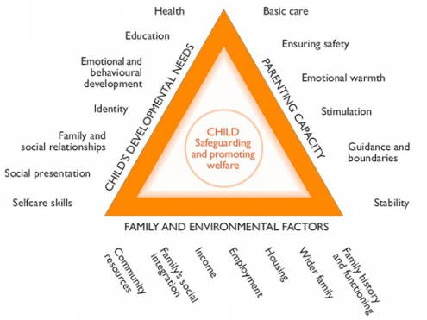

You can now click on the Detail tab at the top of the window to add further detail about your concern. This information will be restricted based on the clearance level that you set, so you can go into more detail about the reasons for your concern.

There is also a body map here. You can click locations on the body map, relating to injuries or marks on the child that you wish to take a note of.

Finally, go to the Documents tab if you wish to upload any documents that relate to your concern and click Save at the top right. Once the information has been reviewed, you will receive an email.

