Place a Pupil on Report via the Main Menu

This guide explains how to place a pupil on report via the PARS main menu. On Report cards issued in this manner are not linked to behaviour incidents. To begin go to:
Main menu > On report > On report episodes

Click the Add button at the top of the page and a student selector window will open. Select the pupil(s) that you want to place on report then click Accept.

Next select the type of report card you want to issue from the drop down. Use the Start and End date selectors to set the time period over which you want the pupil to be on Report, then click the Add button.

The On Report Card will then appear in the white space in the middle of the window. If you need to remove the On Report, click the red cross in the Remove column.

Report Cards are either fixed or dynamic. A fixed report card will always have the same targets, whereas dynamic report cards can have a different set of targets for different pupils. There is a dynamic column in the behaviour entry window. If you see a green plus symbol in this column, the report card is dynamic.

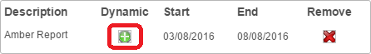

If the report card is dynamic then you will need to select the targets that will appear on the pupil’s on report card. Click the green plus button to select the targets.

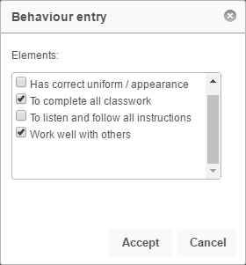

Once you have selected the targets click Accept. If you are adding a fixed report card instead of a dynamic, you can skip this step.

Finally click Save in the behaviour entry window to save the behaviour incident and place the pupil on report.

