Place a Pupil on Report via a Behaviour Incident

Prerequisite Knowledge
This training guide assumes you know how to add a behaviour incident. If you do not, see the Add a behaviour incident via a register or the Add a behaviour incident via the main menu guide.

Placing a Pupil on Report
Open the behaviour entry window for one or more pupils. You must be issuing a negative or neutral behaviour incident in order to give place a pupil on report.

Click on the On Report tab at the top of the window. Select the type of report card you want to issue from the drop down. Use the Start and End date selectors to set the time period over which you want the pupil to be on Report, then click the Add button.

The On Report Card will then appear in the white space in the middle of the window. If you need to remove the On Report, click the red cross in the Remove column.

Report Cards are either fixed or dynamic. A fixed report card will always have the same targets, whereas dynamic report cards can have a different set of targets for different pupils. There is a dynamic column in the behaviour entry window. If you see a green plus symbol in this column, the report card is dynamic.
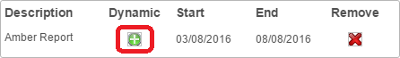

If the report card is dynamic then you will need to select the targets that will appear on the pupil’s on report card. Click the green plus button to select the targets.

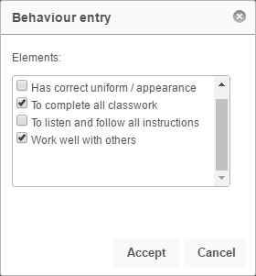

Once you have selected the targets click Accept. If you are adding a fixed report card instead of a dynamic, you can skip this step.

Finally click Save in the behaviour entry window to save the behaviour incident and place the pupil on report.

