Manage Permissions

Each user in PARS has their own set of permissions, which govern what the user can do in PARS and what menu items they are able to see. Users’ permissions may need to be updated if they cannot perform certain tasks in PARS e.g. teachers need to have the permission to take registers, otherwise they cannot register their classes. New users accounts do not have any permissions so new teachers will need to have permissions given to them, otherwise they will not be able to do anything in PARS.

Accessing the Permissions Page
To access the permissions page go to:
Main menu > System management > Permissions

There are two views for the Permissions page; Templates and Users. You can switch between the two views by using the radio buttons at the top of the page.

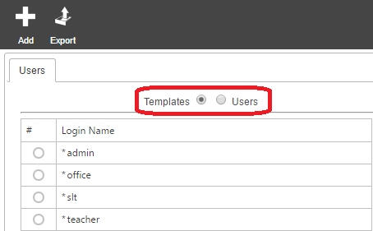

Permissions should be managed by using templates. You should create a few templates that cover the needs of various types of staff in school i.e. admin, teacher, office, etc.

Staff should then have a template assigned to them. The benefits of using templates in this way are:
- All staff on a template have the same permissions so you can be sure every member of staff on that template has the same access rights
- If you need to change the permissions given to staff, you can modify the template instead of modifying the permissions for every individual staff member

Creating a New Permissions Template
Click the Add button at the top left of the page to create a new permissions template. A window will appear where you can name the template. Name the template and click Accept. The new template will now appear in the list of templates. Select it using the radio button to the left then click Modify.

You can manually set the permissions for the template if desired. To this, click on the arrow next to a section to expand that section. Then select the permissions you want to turn on using the checkboxes.
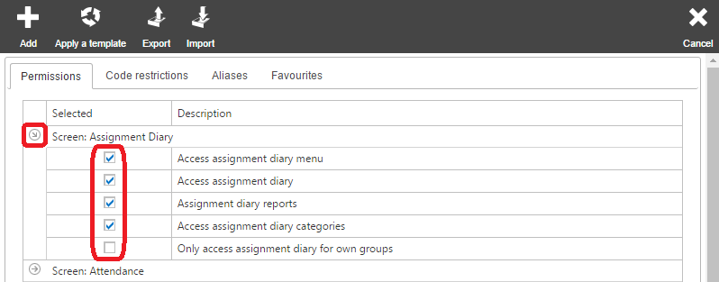

Alternatively you can import a permissions template into PARS. There are several templates available on our wiki via: http://www.tascsoftware.co.uk/wiki/PARS_Connect/index.php?title=Permissions#Permissions

Once you have a template to import, click the Import button on the top toolbar. Select the permissions file and click Ok.

Once you are happy with your permissions template, click the Save button at the top right of the page.

Applying Permission Templates to Users
Click on the Users button at the top of the Permissions page to go to the Users view. You will now see a list of SIMS users. You can reorder the list of users by clicking on the column headers (e.g. Surname) to order the list by that column.

Select all of the users that you want to apply a permissions template to then click the Modify button. This will take you to a new page. Click the Apply a template button at the top of this page and select the template that you want to apply to the users. Click Ok once you have selected the template, then click the Save button at the top right of the page.

Modifying Templates
If you want to amend users’ permissions, you should make the changes to the relevant permission template and re-apply that template to the users.

To make changes to templates, go to the Templates view by clicking the Templates button at the top of the page.

Select the template you want to edit then click the Modify button. This will open the list of permissions. Make whatever changes are required then click the Save button at the top right. This will take you back to the permissions page.

Although the template has been altered, the changes have not yet been applied to users. Select the template then click the Manage button on the top toolbar. This will open another window; click the Reapply button in this window to push the changes out to all users who are associated with that template.

