Create SEND Support Plans (SSPs)

SSP templates can be imported into PARS so that students’ SSPs are stored, accessed and managed in PARS. All typing and data entry for the SSP can be done directly in PARS and will be saved on the student’s SSP electronically.

Creating an SSP template
SSPs are first created using Word then imported into PARS. Open Word (or a similar text editor) to begin creating an SSP template.

To begin open a new Word document. Tables are used to create SSP templates. The example SSP template below has 8 rows and 4 columns (columns/rows can be merged).
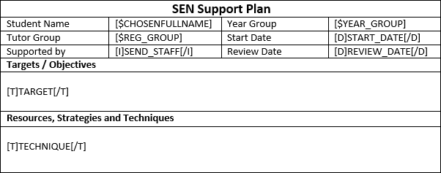

Insert a table into your Word document with approximately the number of rows and columns required. Columns and rows can be added or removed later, as needs be.

Tables are usually accessed via: Insert > Table. This may vary between different versions of Word.

Your SSP template can include fixed text (this is writing that never changes). This is entered onto the SSP template by typing whatever text you want to appear.

The SSP can also include Data Entry fields and Data Import fields. Data Entry fields are used where you want somebody to enter information into the SSP using PARS. Examples of this are dates and comments. Data Import fields are used where you want the SSP to automatically import data from SIMS, such as the student’s name or tutor group.

Special codes have to be typed into the SSP template in order for Data Entry and Data Import fields to work.

The previous example has been colour coded. Areas with fixed text are green, Data Entry fields are red and Data Import fields are blue.
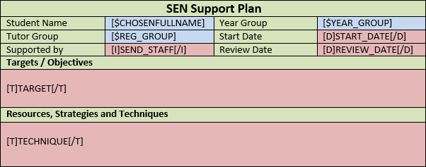

The Student Name and Year Group will automatically be imported into the template when it is used in PARS. The rest of the fields need to be filled in by a user in PARS.

Data Import Fields
To use a data import field, you type a specific code into your SSP template in Word. When the SSP is used in PARS, the code will be replaced by the information about the student, like a mail merge field.

The fields are available are:
Data Import Fields

Data shown in PARS | Code typed into SSP template
Chosen name | [$CHOSENFULLNAME]
Date of birth | [$DATEOFBIRTH]
Age | [$AGE]
Forename | [$FORENAME]
Surname | [$SURNAME]
Admission number | [$ADMISSION_NUMBER]
Parent salutation | [$SALUTATION]
UPN | [$UPN]
Gender | [$GENDER]
House | [$HOUSE]
NC year | [$NC_YEAR]
Tutor group | [$REG_GROUP]
Year group | [$YEAR_GROUP]

If you type normal text into your SSP template, it will appear in PARS exactly as you typed it. The fields from the table above will pull data from SIMS into the SSP.

For example you might enter the following into your SSP template in Word:
Name | [$CHOSENFULLNAME]
Date of Birth | [$DATEOFBIRTH]

This would appear in PARS as:
Name | John Smith
Date of Birth | 01/01/2005

Data Entry Fields
Data Entry fields are used where you want users to enter information onto the SSP. As with Data Import fields, there are specific codes that need to be used for this.

The fields are available are:
Data Entry Fields
Data Entry Type | Code typed into SSP template | Output
Textbox | [T]FIELD_NAME[/T] | The standard feature used to allow users to type unlimited text into an SSP. The SSP will automatically resize to accommodate the text.
Input box | [I]FIELD_NAME[/I] | A limited textbox where users can only enter 25 characters. If users need to enter more data, use a textbox instead.
Date selector | [D]FIELD_NAME[/D] | The feature for adding dates to SSPs.
Checkbox | [C]FIELD_NAME[/C] | This produces a tick box which users can tick or untick.
Dropdown | [S]FIELD_NAME[/S]  [o]option1[/o]  [o]option2[/o]  [o]etc.[/o]  [.] | This will produce a dropdown of options.  The text entered between [o] and [/o] will appear as an option in the dropdown menu.

When entering Data Entry codes onto your SSP template, you should replace “FIELD_NAME” with a unique name for the data entry field i.e. you would enter [I]MENTOR_NAME[/I] where you want a user to type the student’s mentor’s name, instead of [I]FIELD_NAME[/I]

No Data Entry fields should have the same name. This (below) will not work properly in PARS because the two Data Entry fields have the same name:
Form Tutor comments | [T]COMMENT[/T]
Head of Year comments | [T]COMMENT[/T]

Instead you should give each field a unique name:
Form Tutor comments | [T]COMMENT_1[/T]
Head of Year comments | [T]COMMENT_2[/T]

There should not be any spaces in your field names. If you need to separate two words use an underscore i.e. MENTOR_NAME rather than MENTOR NAME

PARS will only accept SSP templates when they are .htm format. To convert your Word document to .htm go to File > Save As…
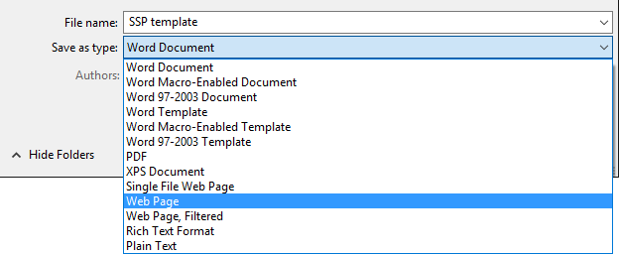

In the Save as type section, select Web Page then save your SSP template. Saving the document as a Web Page converts the document to .htm

Importing the template into PARS

Once you have created your SSP template it needs to be imported into PARS. To do this go to:
Main menu > Personal > SSP writer designs

Click the Add button on the top toolbar. This will open a window where you can select your SSP template from your computer. Select the SSP template and click Open.

The SSP will then appear in PARS. Click the Save button on the top toolbar and give the SSP template a name that will be seen in PARS. Finally click Save to finish importing your SSP template into PARS.

