Run a Homework Report

This guide will explain how to run a single homework report. Reporting features such as hiding columns, filtering data and automating the report will be covered.

# Running the Homework Report

To access homework reports go to:

**Main** **menu** > **Assignment diary** > **Assignment reports**

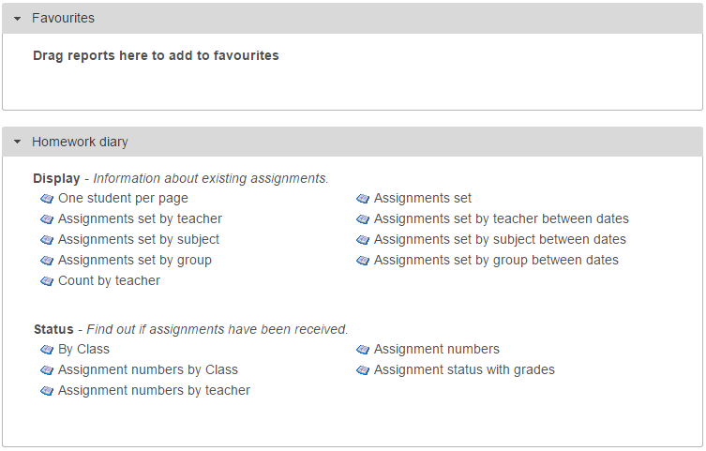

Click on **Assignment diary** to expand the section then from the **Display** section, click on the top left report, **Assignments set**.

A date selector window will now appear. At the bottom left of the window there is a list of vulnerability groupings that you can choose to show on your report. Select any of the groupings you want on your report.

Next choose the date range. Click the **Year to date** link on the left of the window, then click **Accept**.

A student selection window will now open. Select a student then click **Accept.**

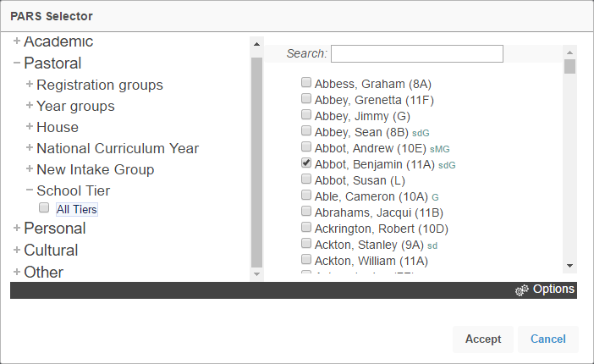

Your report will then open in a new window.

*If your report does not open, check that your pop-up blocker has not blocked pop-ups from PARS.*

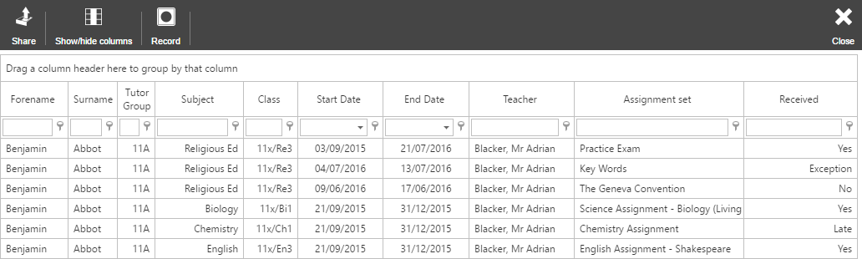

# Features in Reports

## Hiding Columns

To hide columns from your report, click the **Show/hide columns** button on the top toolbar. This will open a window with a list of all of the columns that are available on the report. Deselect any columns you wish to hide.

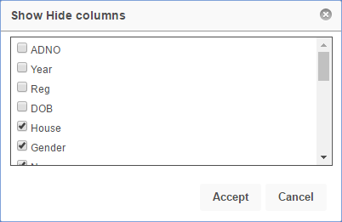

## Ordering Data

To order the data on the report (e.g. highest to lowest) click on the column header for the column you want to order. Click the column header once to order lowest to highest, or twice to order highest to lowest.

In the report in our example, click the **Date** column header twice to order highest to lowest based on the date of the homework. The most recent homework assignments will appear at the top of the report.

## Filtering

The data in the report can be filtered e.g. only show instances where the pupil has not completed their homework. To do this, first select the column you are going to filter. The **Received** column shows the type of detention that has been given to the pupil.

Beneath the column header there is a textbox and a button that looks like a pin.

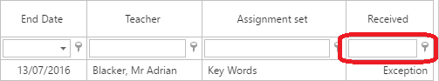

Click on the pin button to see the options for filtering. For this example, select **Not Equal**. Next type the word you want to use for filtering into the textbox, such as “Yes”.

The report will now only homework assignments that the pupil did not complete on time.