Create and Mark Homework

Prerequisite Knowledge
Homework is usually created and managed via registers, therefore you should know how to access a register before reading this guide. If you do not, see the Take a register guide for more information.

Accessing the Assignment Diary
Homework is managed using the assignment diary, which can be accessed either via a register or through the main menu. The route through the main menu is:
Main menu > Assignments > Assignment diary

In a register, the Assignments button can be seen on the top toolbar.

The word “Assignments” can be changed via the preferences page in PARS, so you may not see the word Assignments. Schools often replace this with Homework.

Creating Homework Assignments
Click the Add button on the right of the assignment diary to create a new piece of homework. There are three tabs available when creating a homework assignment. The Details and Attachments tab are used to create the assignment, and the Assignees tab is used to mark it.

Details
The basic information about the assignment should appear on this tab. The Title and Description of the homework must be entered, as well as the Start and End date. The Start date will default to the date of the class, if the assignment diary was accessed via a register. The End date is the due date for the assignment.

You can specify a Category, although this is optional. Categories need to be configured in PARS so it is possible that no categories will be available.

The Grade dropdown is used to select a type of grade that will be used to mark the homework e.g. percentage, numeric, etc. This is optional.

The assignment diary uses gradebook elements for grading. The Create teacher gradebooks guide explains how these elements are configured.

Attachments
Use this tab to upload any files relevant to the assignment. If you are using Insight (our online parental portal) then these attachments will be available to parents and/or students online via Insight.

Once you are happy with the assignment click the Accept button to save it.

Mark the Homework
In the Assignment Diary, click on the piece of homework you want to mark to select it then click the Edit button on the right side of the window.
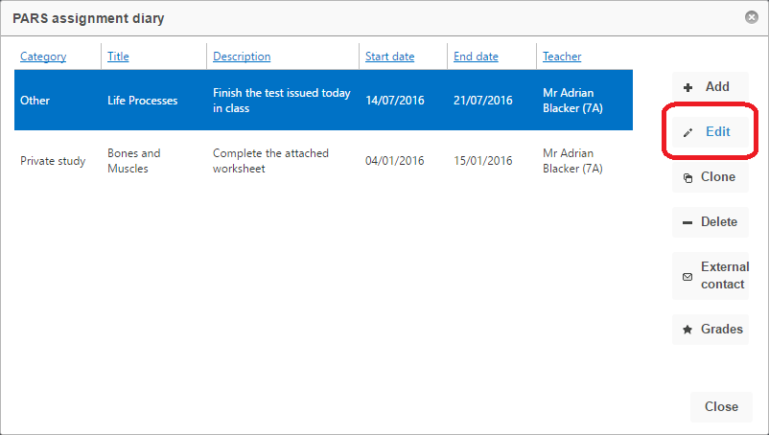

Your assignment will now open. Click on the Assignees tab at the top of the window. A list of the students in the class will be shown. There are four icons next to each pupil’s name.

The assignment was completed on time
The assignment was completed but handed in late
The assignment was not completed
The student was excused from completing the assignment

Click on an icon next to a pupil to mark their homework. If you want to give an extension to a pupil, enter the new due date in the End date field next to their name. The same can be done for alternative start dates.

