Entering Grades

Grades can be entered via PARS. Aspects from SIMS Assessment Manager can be imported into PARS and grades entered into these aspects in PARS will immediately write back to SIMS.

Accessing the Grade Entry Screen
The Grade Entry screen is used in PARS to record grades, rather than using Marksheets as in SIMS. There are three ways to access the Grade Entry screen in PARS.

Via the Main Menu
To access the Grade Entry screen via the Main menu, go to:
Main menu > Grading > Grade entry > Enter grades

Select the class that you want to enter grades for then click Accept.

Via the Homepage / Timetable
Each of your classes will be shown on your timetable as a small box. Clicking on the box will open the register for that class. Inside each box there is a star; clicking the star will open the Grade Entry screen for that class instead of the register.
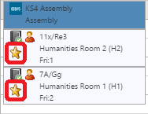

Via a Register
The Grade Entry screen for a class can be accessed from the register for that class. From a register click the Grades button to open the Grade Entry page for that class.

The Grade Entry Screen
Each student from the class will be shown on the left side of the screen. One column will appear for each of the grades that needs to be entered.

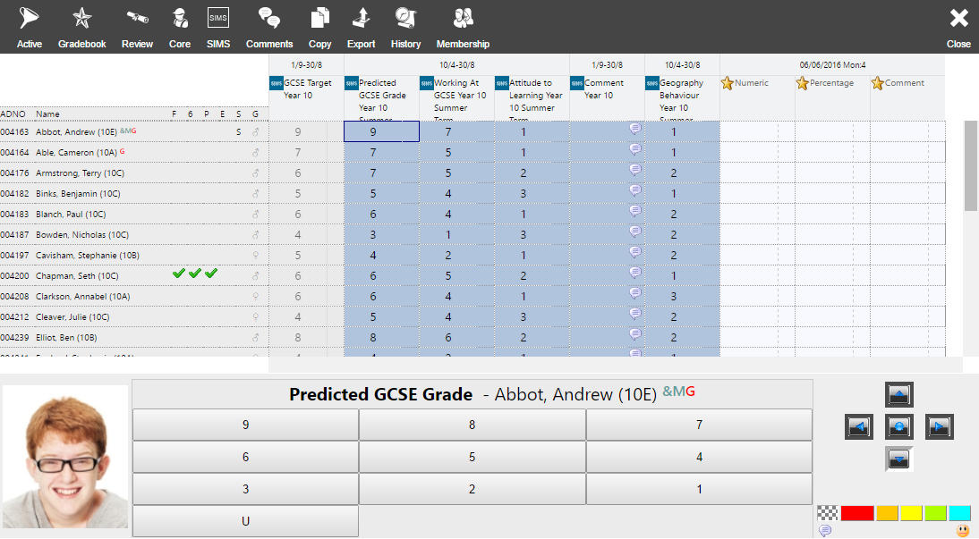

By default the grade entry screen will show the Active view. This is a filtered view that only shows the grades that need to be entered at this point in time.

You can see all grades that have been entered over the course of the year by clicking on the SIMS button on the top toolbar. The Active button is used to switch back to the Active view.

Any columns that are greyed out are read-only columns. Some columns may be read-only throughout the whole year. Other columns will lock and unlock themselves automatically based on the date range for data entry.

Entering Grades and Comments
To enter a grade, click in the column you want to use. The selected pupil’s photograph and a list of the available grades for that column will be shown at the bottom of the page. Click on the grade you want to give to the pupil.

To enter a single comment, click on the right side of a grading cell.
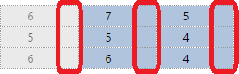

This will open a window where you can type a comment. In the comment window you can click
Insert > Comment to select comments from the comment bank (if configured).

Comments can be added for multiple pupils at once by clicking the Comments button on the top toolbar and selecting the pupils that you want to add comments for.

One you have finished adding the grades and comments, click the Save button at the top right of the page.

