Create a Comment Bank

A bank of comments can be created in PARS so that staff can select pre-configured comments rather than typing the comments themselves. Comments can include mail merge fields to automatically fill information about a student, such as their name or he/she (depending on the student’s gender).

To create a comment bank go to:
Main menu > Grading > Configure > Configure comment bank

Add Comments Manually
To add a new comment, first select the subject that the comment applies to from the dropdown at the top right of the page.
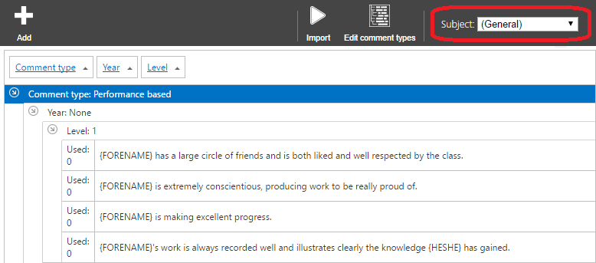

Once you have selected a subject click the Add button to add a new comment. This will open a window where you can type the comment. On the right of the window there are buttons you can use to add mail merge fields to the comment, such as Forename and He/She.
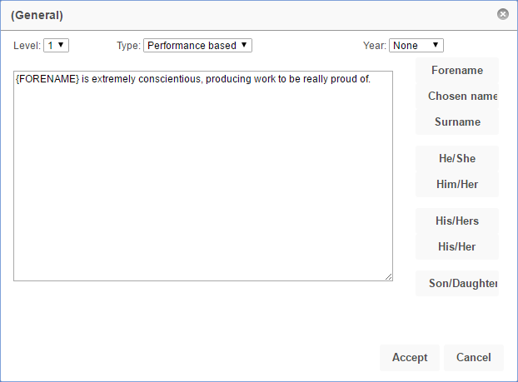

At the top of the window there are dropdowns to select the Level, Type and Year for the comment.

The level indicates how well the pupil has performed. 1 is the best level, 2 is slightly worse and so on. The Type is either performance based or target based (e.g. comments about the work the pupil has already done, or what they need to do next).

If the comment is Year Group specific then select the relevant year from the dropdown, otherwise leave the Year dropdown set to None. Click Accept to save your comment to the comment bank.

Importing Comments from a CSV File
Comments can also be imported from a CSV file. The file will need to be formatted as follows:
[Type],[Level],[Comment],[Year]

[Type] will either be 1 or 2; 1 for Performance based comments and 2 for Target based.
[Level] is the number of the level given to the comment. Every comment must have a level.
[Comment] is the actual text for the comment. If the comment contains commas then the whole comment must appear inside quotation marks e.g. “Your work is very, very good”.
[Year] is only used if the comment is year-specific, in which case two numbers should be used to represent the year group e.g. 07 or 11. Leave this blank if the comment is not year-specific

The CSV file would then look something like this:
1,1,”Your work is very, very good.”,
1,3,Your work has not been good enough.,
2,3,You must improve before your GCSE exams next year.,10

Once you have a CSV file to import click the Import button and a window will open.
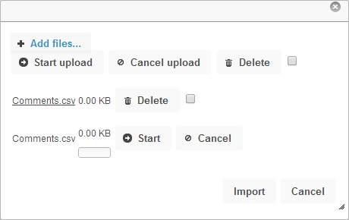

Click the Add files button and select the CSV file from your computer. Then click the Start button to begin uploading the file. When the file has finished uploading you will then need to click Import for the comments to be imported into PARS.

