Run an Extra Class Report

This guide will explain how to run a single extra class report. Reporting features such as hiding columns, filtering data and automating the report will be covered.

Running the Extra Class Report
To access extra class reports go to:
Main menu > Extra classes > Extra class reports

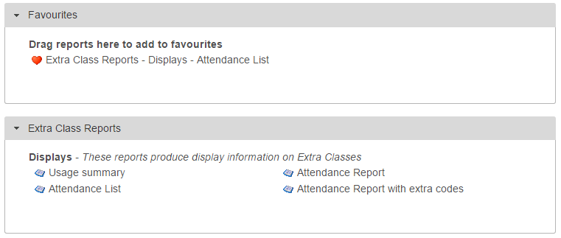

Click on Extra class reports to expand the section then click on Attendance list.

A date selector window will now appear. At the bottom left of the window there is a list of vulnerability groupings that you can choose to show on your report. Select any of the groupings you want on your report.

Next choose the date range. Click the Last week link on the left of the window, then click Accept.

A student selection window will now open. Select all students using the All tiers option on the left side of the window, under the School Tier section.

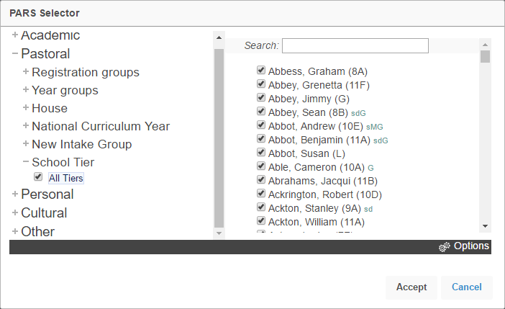

Your report will then open in a new window.
If your report does not open, check that your pop-up blocker has not blocked pop-ups from PARS.

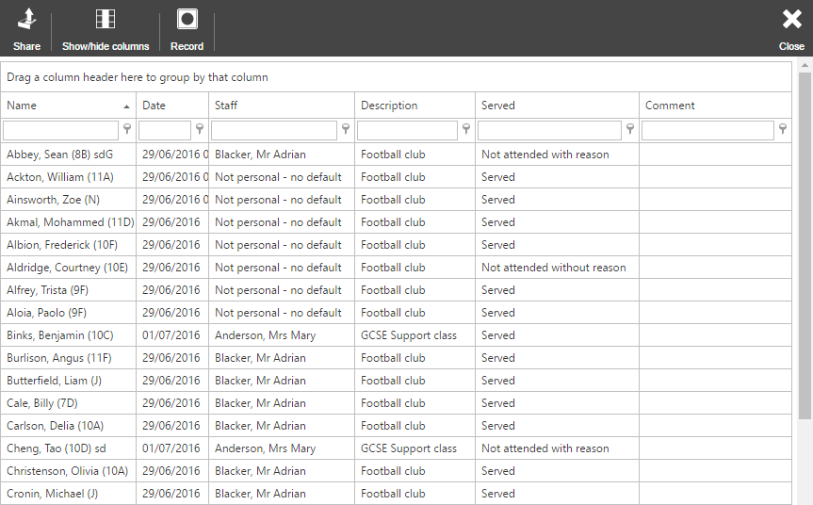

Features in Reports

Hiding Columns
To hide columns from your report, click the Show/hide columns button on the top toolbar. This will open a window with a list of all of the columns that are available on the report. Deselect any columns you wish to hide.
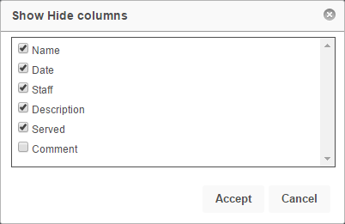

Ordering Data

To order the data on the report (e.g. highest to lowest) click on the column header for the column you want to order. Click the column header once to order lowest to highest, or twice to order highest to lowest.

In the report in our example, click the Date column header twice to order highest to lowest based on the date of the extra class. The pupils in the most recent extra class will appear at the top of the report.

Filtering

The data in the report can be filtered e.g. only show pupils with specific types of extra classes. To do this, first select the column you are going to filter. The Description column shows the type of extra class that the pupil was supposed to attend.

Beneath the column header there is a textbox and a button that looks like a pin.

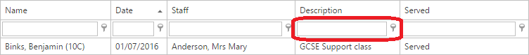

Click on the pin button to see the options for filtering. For this example, select Begins with. Next type the name of the detention you want to use for filtering into the textbox, such as “GCSE Support”.

The report will now only show pupils who should have attended that type of extra class last week.

