Create a New Type of Extra Class

Extra Classes must be configured in PARS before they can be issued by staff. They are configured via:
Main menu > Extra classes > Configure > Configure time types

Creating the Extra Class
Click the Add button on the top toolbar to create a new type of extra class. A window will open with several options. The Description is the name of the class. The Code is an abbreviation of the Description.

You can enter a maximum number of pupils for the extra class if required, or leave the setting at zero if there is no limit. You should always enable the Schedule only timeslot option.

The Default to personal option is used to denote whether the extra class is personal or non-personal. Personal extra classes are your own; you have put the pupils into the extra class and you will be taking the register yourself. Other staff cannot put pupils into your personal extra class. Non-personal extra classes are centralised and registers can be taken by anyone.

Enter the start and end time for the extra class. You can type the times into the textbox instead of using the sliders if you find it easier. The times should be formatted hh:mm.

If the extra class will always take place in the same room then you can select a default room. Leave this field blank if the detention can take place in multiple rooms.

The list of rooms will be blank if they have not yet been imported from SIMS. See the Create a new behaviour structure in PARS or the Import the behaviour structure from SIMS guides for information about importing rooms.

If the extra class will always be taken by the same member of staff then you can select a default teacher. Otherwise leave this field blank.
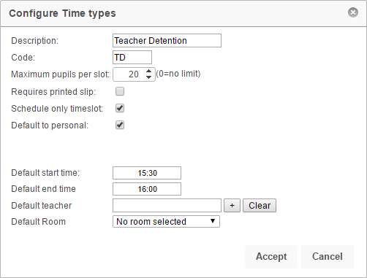

Once you are happy with the settings for your extra class, click the Accept button.

Scheduling the Extra Class
Once an extra class has been created, PARS needs to be told when it is going to take place e.g. Fridays only, every day, etc.

To do this, first click on the extra class then click the Calenderise button on the top toolbar.

In the window that opens, set the start date to today and the end date to the end of the academic year. The start and end time will automatically be picked up from the settings entered when creating the detention.

Tick the days of the week when the extra class should take place. The Exclude holidays option will prevent detentions from being scheduled during half term, public holidays, inset days, etc. Click Accept to schedule your extra class.

You can schedule a detention more than once if you want it to happen multiple times per day.

An example of this could be Revision Drop-In Clubs, which could take place during lunch or after school.

You would schedule the class once, from today until the end of the year, with a start and end time to cover the lunch slot.

You would then schedule the same class again, from today until the end of the year, this time setting the start and end time to cover the after school slot.
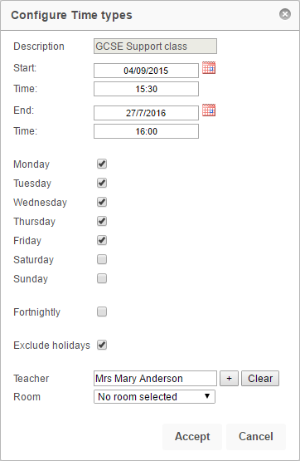

Limiting the Extra Class to Certain Staff
Extra Classes can be restricted so that only certain staff are able to issue them. To do this, click on a extra class then click the Allowed users button. The window that opens will show the staff who are allowed to use this class. If the window is empty, all staff are allowed to use it.

Click the Add button to add staff to the list of allowed users. Select the required staff from the staff selector window then click Accept. To remove staff from this list, select them using the checkboxes on the left then click Remove. Click Accept when you are finished.
