Add Pupils to Extra Classes

Pupils need to be added to an extra class before they can be seen in a register. This guide will explain how to add pupils to extra classes so that registers can be taken for them. This guide does not cover the process for creating extra classes. See the Configure extra classes guide for more information about the required setup.

There are two methods that can be used to place pupils in an extra class. Pupils can be added to an extra class for a date range and they will appear in every register for that extra class, over the chosen date range. Alternatively pupils can be added as a one-off to a single extra class register.

Adding Pupils to all Registers for an Extra Class over a Date Range
To add pupils to an extra class go to:
Main menu > Extra classes > Edit extra class membership

A student selector window will open. Select the pupils that you want to place into an extra class then click Accept. A list of the extra classes that the pupil(s) have already been added to will be displayed. Use the Add button to place the pupils into a new Extra Class.
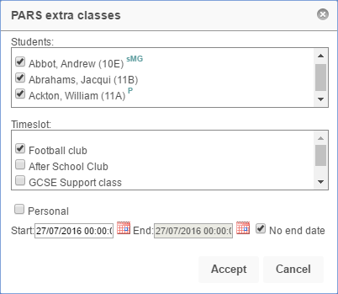

Select the type of extra class that you want to place the pupils into, from the list in the window. Choose the start date and end date for the pupils’ membership to the extra class. If you want the pupils to remain in the extra class indefinitely then select the No end date option. Once done click Accept.

Adding Pupils via a Register
Pupils can be added directly into an extra class register. When pupils are added using this method, they will only appear in that single register. This is often used for extra classes that pupils can drop into at their own discretion.

Open the register that you want to add one or more pupils to. Once the register is open click the New arrival button on the top toolbar. A student selector window will open. Select the pupils you want to add to the register then click Accept.
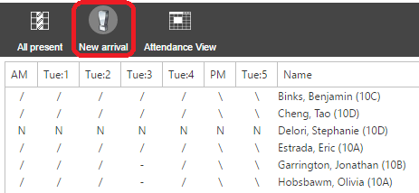

For information about how to open and take an Extra Class Register, see the Take an extra class register guide.

