Take a Detention Register

Prerequisite Knowledge
This guide explains how to take a detention register. It does not cover the process for issuing detentions to pupils. See the Add a detention via a behaviour incident and the Add a detention via the main menu guides if you do not know how to add detentions.

Accessing Detention Registers
There are two types of detention registers; personal and non-personal. Personal detentions are your own detentions; you have put the pupils in detention and you will be taking the detention register. Other staff cannot put pupils into your personal detention. Non-personal detentions are centralised detentions such as Head of Year detentions.

Personal Detentions
Registers for personal detentions can be seen on your timetable on the PARS Home Page. Click the house button on the top toolbar of PARS to access the Home Page.

Personal detention registers will appear as purple boxes on your timetable. Click on the register to open it.
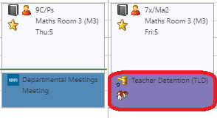

Non-Personal Detentions
Non-Personal detentions will not appear on your timetable. To access registers for these detentions go to:
Main menu > Detentions > Take detention registers

A list of the day’s detention registers will be shown. Click on the register that you want to take, then click the Take this register button on the top toolbar to open the register.

Taking the Register
The detention register will show a list of the pupils in that detention. The attendance marks for each pupil will be shown to the left of their names so you can see whether they are absent.
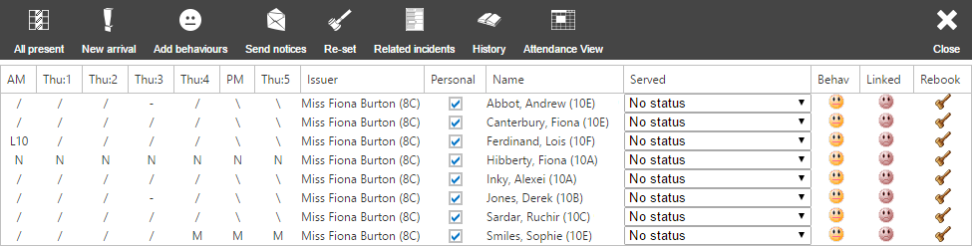

You can see a list of the behaviour incidents that caused the pupils to be placed in detention by clicking the Related incidents button on the top toolbar.

The Served column is used to mark the pupils in the register. The available marks are:
Mark | Meaning
No status | No mark has been recorded yet
Served | The pupil attended the detention
Not attended with reason | The pupil did not attend, but with good reason
Not attended without reason | The pupil did not attend

Use the dropdowns in the Served column to mark each pupil. You can also click the Mark all present button on the top toolbar to change all of the No status marks to Served. Once you have marked the pupils click the Save button on the top toolbar.

If any pupils who are not on the register arrive to your detention, you can add them to the register by clicking the New arrival button on the top toolbar. A student selector window will open. Choose the students who have arrived and click Accept.

If you want to give new detentions to pupils who have not attended, click the Re-set button. This will give a new detention to each pupil who has a certain mark in the register. Select the mark in the window that opens.
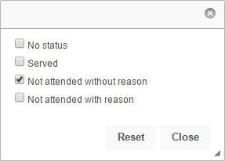

Once you have selected the mark click Accept. A window will open allowing you to issue a new detention to all pupils with the selected mark.

