Run a Detention Report

This guide will explain how to run a single detention report. Reporting features such as hiding columns, filtering data and automating the report will be covered.

This guide uses a single report for demonstration purposes and does not offer guidance as to which detention reports should be used for various purposes. See the Suggested detention reports guide for a list of useful detention reports.

Running the Detention Report
To access detention reports go to:
Main menu > Detentions > Detention reports

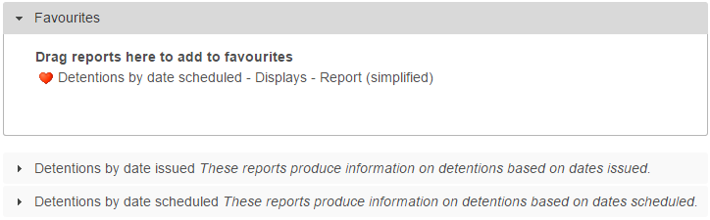

Click on Detentions by date scheduled to expand the section then from the Displays section, click on the top left report, Report (simplified).

A date selector window will now appear. At the bottom left of the window there is a list of vulnerability groupings that you can choose to show on your report. Select any of the groupings you want on your report.

Next choose the date range. Click the Next week link on the left of the window, then click Accept.

A student selection window will now open. Select a year group of students by clicking the Year groups section on the left of the window, then using the checkboxes to select a year group.

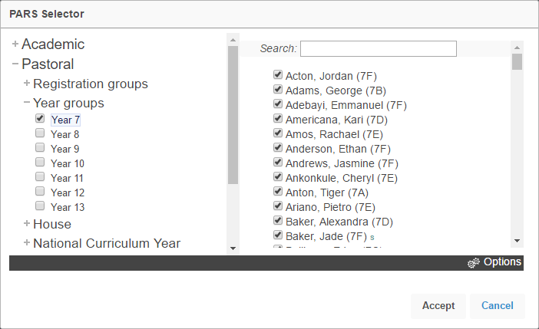

Your report will then open in a new window.
If your report does not open, check that your pop-up blocker has not blocked pop-ups from PARS.
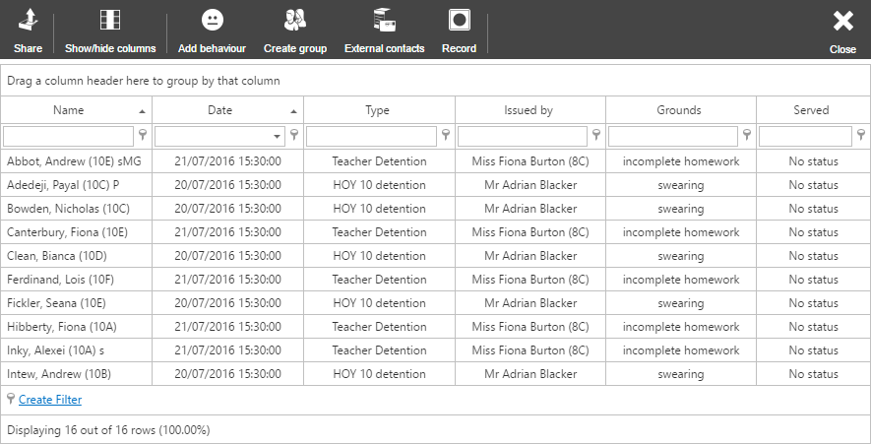

Features in Reports

Hiding Columns
To hide columns from your report, click the Show/hide columns button on the top toolbar. This will open a window with a list of all of the columns that are available on the report. Deselect any columns you wish to hide.

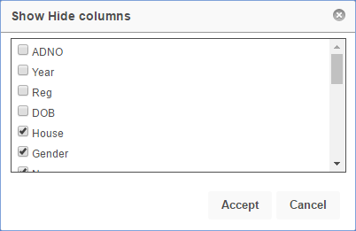

Ordering Data

To order the data on the report (e.g. highest to lowest) click on the column header for the column you want to order. Click the column header once to order lowest to highest, or twice to order highest to lowest.

In the report in our example, click the Date column header twice to order highest to lowest based on the date of the detention. The pupils with the soonest detentions will appear at the top of the report.

Filtering

The data in the report can be filtered e.g. only show pupils with specific types of detentions. To do this, first select the column you are going to filter. The Type column shows the type of detention that has been given to the pupil.

Beneath the column header there is a textbox and a button that looks like a pin.

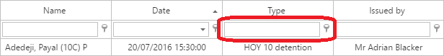

Click on the pin button to see the options for filtering. For this example, select Equals. Next type the name of the detention you want to use for filtering into the textbox, such as “HOY 10 detention”.

The report will now only show pupils with that type of detention, occurring next week.

Automating the Report

In PARS reports can be automated. This means the report will automatically be emailed to one or more email addresses, once or more a week. Filters can be applied to automated reports, data can be ordered and columns can be hidden.

First configure the report so that it looks exactly as you want it e.g. apply filters, hide columns, etc.

Next click the Automate button on the top toolbar. This will open a window with various options for automating your report.

Your automated report will need a job name. It is recommended that you start with your initials, as this will make it easier to identify your own reports from the list of all automated reports in the future.

Choose a timeframe for your report. This is the date range that the report will use when it is sent. Enter one or more email addresses to receive the report, separated by semi colons. You can also click the button next to the email textbox to select staff members. PARS will then find their email addresses for you.

Choose the format that you would like the report to use. XSL and XSLX are both Excel documents. XSLX is slightly more modern than XSL.

Finally choose the day(s) and time you would like the report to be sent. Once done, click the Automate button. Your report will then be added to the automation list.

