Recommended Detention Reports

There are many detention reports in PARS. Screenshots of each report can be found on our wiki page. This guide explains which detention reports are used by schools for common tasks.

This training guide assumes that you know how to run detention reports. If you do not, see the Run a detention report guide.

First, go to the detention reports page:
Main menu > Detentions > Detention reports

Detentions on a Specific Date with Behaviour Information
This report shows the detentions that are going to take place over a chosen date range. The grounds of the related behaviour incidents will be shown, if applicable. The report is accessed via:
Detentions by date scheduled > Displays > Report (simplified)
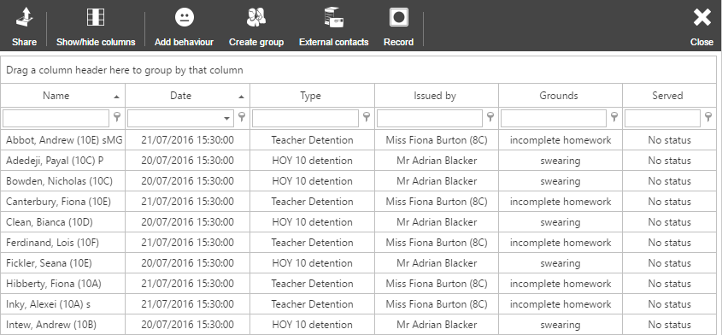

Detention Count by Pupil
This report is used to show the total number of detentions that each pupil has received, and how often they have attended. The report is accessed via:
Detentions by date scheduled > Summaries > Count report
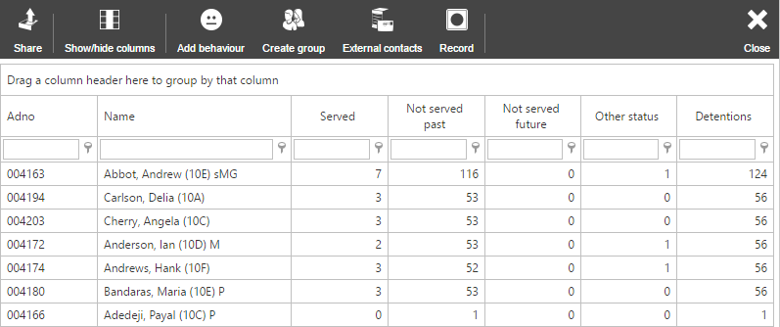

Number of Detentions given per Staff Member
This report shows how many detentions each staff member has given. The report is found via:
Detentions by date issued > Issuers > Count
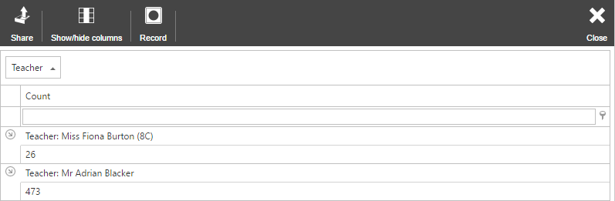

List of Behaviour Incidents, Detentions, Report Cards and Contact History
This report shows a full log of behavioural information for a student. This report is accessed via:
Behaviour displays > Individual > Behaviour chronology
