Create a New Type of Detention

Detentions must be configured in PARS before they can be issued by staff. Detentions are configured via:

**Main menu** > **Detentions** > **Configure** > **Configure time types**

# Creating the Detention

Click the **Add** button on the top toolbar to create a new type of detention. A window will open with several options. The Description is the name of the detention. The Code is an abbreviation of the Description.

You can enter a maximum number of pupils for the detention if required, or leave the setting at zero if there is no limit. You should always enable the Schedule only timeslot option.

The Default to personal option is used to denote whether the detention is personal or non-personal. Personal detentions are your own detentions; you have put the pupils in detention and you will be taking the detention register. Other staff cannot put pupils into your personal detention. Non-personal detentions are centralised detentions such as Head of Year detentions.

Enter the start and end time for the detention. You can type the times into the textbox instead of using the sliders if you find it easier. The times should be formatted hh:mm.

If the detention will always take place in the same room then you can select a default room. Leave this field blank if the detention can take place in multiple rooms.

*The list of rooms will be blank if they have not yet been imported from SIMS. See the* ***Create a new behaviour structure in PARS*** *or the* ***Import the behaviour structure from SIMS*** *guides for information about importing rooms.*

If the detention will always be taken by the same member of staff then you can select a default teacher. If the detention can be taken by more than one member of staff then leave this field blank.

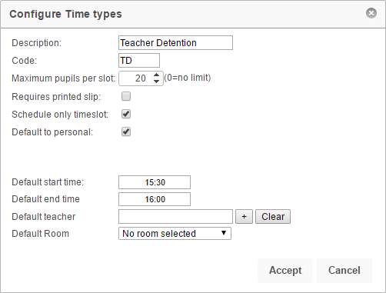

Once you are happy with the settings for your detention, click the **Accept** button.

# Scheduling the Detention

Once a detention has been created, PARS needs to be told when the detention is going to take place e.g. Fridays only, every day, etc.

To do this, first click on the detention then click the **Calenderise** button on the top toolbar.

In the window that opens, set the start date to today and the end date to the end of the academic year. The start and end time will automatically be picked up from the settings entered when creating the detention.

Tick the days of the week when the detention should take place. The Exclude holidays option will prevent detentions from being scheduled during half term, public holidays, inset days, etc. Click **Accept** to schedule your detention.

*You can schedule a detention more than once if you want it to happen multiple times per day.*

*An example of this is Teacher Detentions, which could take place during lunch or after school.*

*You would schedule the detention once, from today until the end of the year, with a start and end time to cover the lunch detention.*

*You would then schedule the same detention again, from today until the end of the year, this time setting the start and end time to cover the after school detentions.*

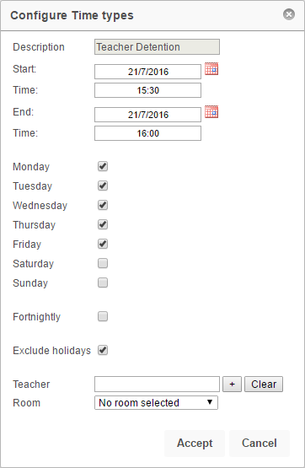

# Limiting the Detention to Certain Staff

Detentions can be restricted so that only certain staff are able to issue them. To do this, click on a detention then click the **Allowed users** button. The window that opens will show the staff who are allowed to use the detention. If the window is empty, all staff are allowed to use the detention.

Click the **Add** button to add staff to the list of allowed users. Select the required staff from the staff selector window then click **Accept**. To remove staff from this list, select them using the checkboxes on the left then click **Remove.** Click **Accept** when you are finished.

