Create a New Type of Detention

Detentions must be configured in PARS before they can be issued by staff. Detentions are configured via:
Main menu > Detentions > Configure > Configure time types

Creating the Detention
Click the Add button on the top toolbar to create a new type of detention. A window will open as below.
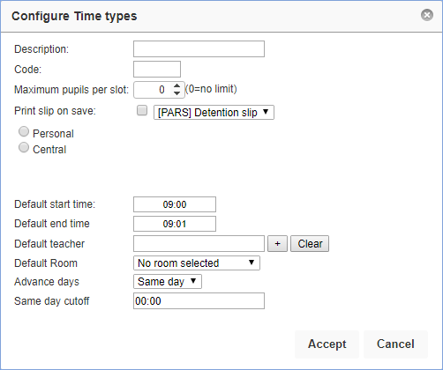

Enter the name of the detention in the Description field. The Code should be an abbreviation of the Description.

You can enter a maximum number of pupils for the detention if required, or leave the setting at zero if there is no limit.

The Print Slip On Save option is used if you want teachers to print detention slips for students immediately as the detention is given. If this is the case you will need to select a Detention Slip for this type of detention. If you do not have a detention slip, please contact our helpdesk.
If you want to print detention slips at a later date, or not print them at all, you should not enable the Print Slip On Save option.

Each detention is either Personal or Central. Personal detentions are used where the person giving the detention to the student will also take the detention register e.g. Teacher Detentions. A member of staff cannot place a student into another staff member’s personal detention.
Central detentions are used where various members of staff can put students in the same kind of detention e.g. Head of Year Detention.

Enter the start and end time for the detention. You can type the times into the textbox instead of using the sliders if you find it easier. The times should be formatted hh:mm.

If the detention will always take place in the same room then you can select a default room. Leave this field blank if the detention can take place in multiple rooms.

The list of rooms will be blank if they have not yet been imported from SIMS. See the Create a new behaviour structure in PARS or the Import the behaviour structure from SIMS guides for information about importing rooms.

If the detention will always be taken by the same member of staff then you can select a default teacher. If the detention can be taken by more than one member of staff then leave this field blank.

Each detention type has an Advance Days setting. This is the minimum number of days in advance that this detention can be booked. If the Advance Days is set to "1 day" then a detention given on Thursday cannot be scheduled to take place until Friday, or later.
If the Advance Days option has been set to "Same day" then the detention is allowed to be scheduled on the same day it is given. In this case you will also see a Same Day Cutoff option. Detentions issued before this time are allowed to be scheduled on the same day, detentions given after this time can only be scheduled the day after or later. If this option is set to 00:00, it is ignored and this detention type can always take place on the same day.
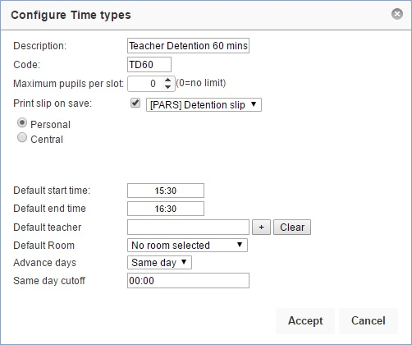

Once you are happy with the settings for your detention, click the Accept button.

Scheduling the Detention

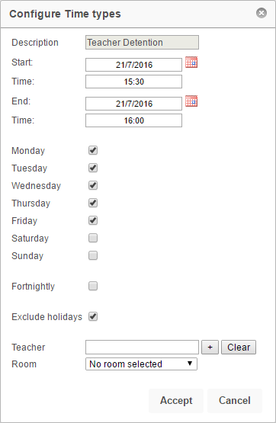
Once a detention has been created, PARS needs to be told when the detention is going to take place e.g. Fridays only, every day, etc.

To do this, first click on the detention then click the Calenderise button on the top toolbar.

In the window that opens, set the start date to today and the end date to the end of the academic year. The start and end time will automatically be picked up from the settings entered when creating the detention.

Tick the days of the week when the detention should take place. The Exclude holidays option will prevent detentions from being scheduled during half term, public holidays, inset days, etc. Click Accept to schedule your detention.

Limiting the Detention to Certain Staff
Detentions can be restricted so that only certain staff are able to issue them. To do this, click on a detention then click the Allowed users button. The window that opens will show the staff who are allowed to use the detention. If the window is empty, all staff are allowed to use the detention.

Click the Add button to add staff to the list of allowed users. Select the required staff from the staff selector window then click Accept. To remove staff from this list, select them using the checkboxes on the left then click Remove. Click Accept when you are finished.
