Change the Date of a Detention

Prerequisite Knowledge
This guide explains how to change the date of a detention once the detention has already been issue. This guide does not explain how to give detentions; if you need information about that see the Add a detention via a behaviour incident or the Add a detention via the main menu guides.

Changing the Date of a Detention
The schedule detentions page is used for this purpose. To access the page go to:
Main menu > Detentions > Schedule detentions

The page will show 7 days’ detentions. To change the date range of detentions that are shown click the Date button at the top left of the page. Select the start date of the detentions you wish to see and PARS will show the detentions for that date and the following 6 days.
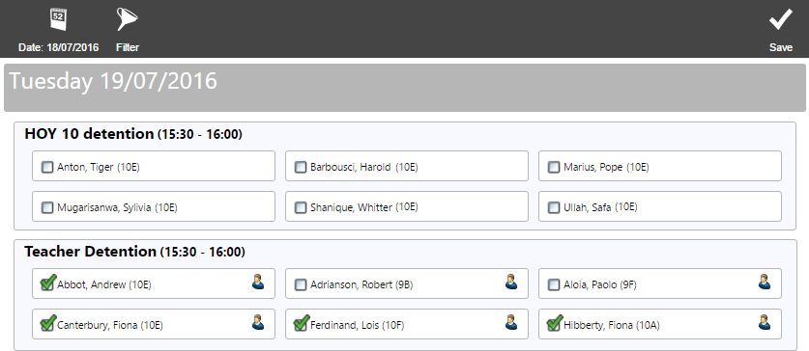

Each detention type for each day will be shown. Pupils who are scheduled to attend a particular detention will have a tick next to their name.

If a pupil does not have a tick next to their name it means that have been issued with that type of detention, but not given a date for that detention to take place. This is called an unscheduled detention.

You can filter the types of detention shown on the page. To do this click the Filter button on the top toolbar. Choose the type of detention you want to see then click Accept.

To remove a pupil from a detention, click the tick next to their name. Their detention will become unscheduled and they will appear, without a tick, underneath every instance of that type of detention that they could attend.
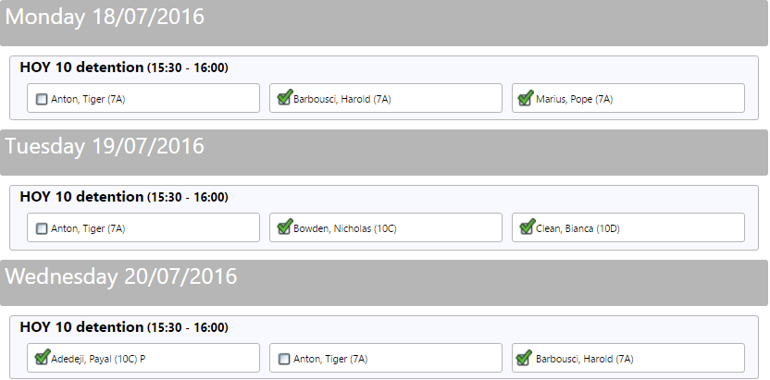

In the image above, Tiger Anton has an unscheduled HOY 10 detention. His name appears in each of the HOY 10 detention slots because he could potentially attend any of them, although he is not actually scheduled to turn up to a slot.

To place a pupil into a detention slot, click the box next to their name. A tick will appear in the box and the pupil will be scheduled to sit that detention. The pupil’s name will disappear from the other detention slots if they do not have any more unscheduled detentions.

When trying to place a pupil into a particular slot, a Select Detention pop up box may appear. This means that the pupil has more than one unscheduled detention, and you must specify which detention you are scheduling.

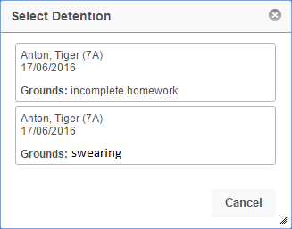

Once you have finished scheduling your detentions click the Save button at the top right of the page.

