Add a Detention via the Main Menu

This guide explains how to add a detention via the PARS main menu. Detentions added in this manner are not linked to behaviour incidents. To begin go to:
Main menu > Detentions > Mark pupils for detentions

A student selector window will open. Select the pupil(s) that you want to give the detention to then click Accept.

Select the type of detention you want to issue from the drop down then click the Add button. If you have added the wrong type of detention click Remove.
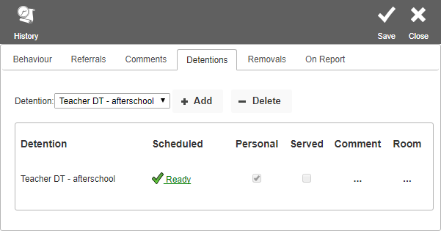

You now need to select the date that the detention will take place. PARS will automatically select the first available date for you. You can see this date and change it if required, by clicking the Ready link. This will open a window as below.

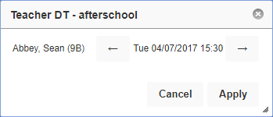

You can move the date of the detention by using the forward and backward arrows.

Note – if you do not click the Ready link, PARS will use the first available date for the detention when you click Save.

When you are happy with the detention, click the Save button at the top right of the page. A report will open in a new tab on your browser showing the date and time that the detention(s) will take place.

