Add a Detention via a Behaviour Incident

Prerequisite Knowledge
This training guide assumes you know how to add a behaviour incident. If you do not, see the Add a behaviour incident via a register or the Add a behaviour incident via the main menu guide.

Issuing a Detention
Open the behaviour entry window for one or more pupils. You must be issuing a negative or neutral behaviour incident in order to give a detention.

Click on the Detentions tab at the top of the window. Select the type of detention you want to issue from the drop down then click the Add button. If you have added the wrong type of detention click Remove. The detention will then appear in the white space in the middle of the window.

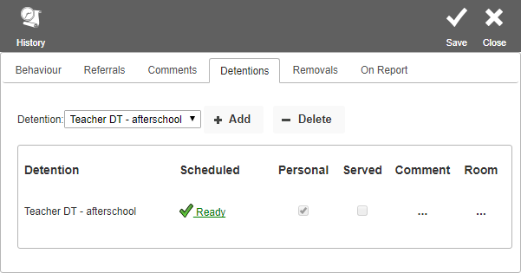

You now need to select the date that the detention will take place. PARS will automatically select the first available date for you. You can see this date and change it if required, by clicking the Ready link. This will open a window as below.
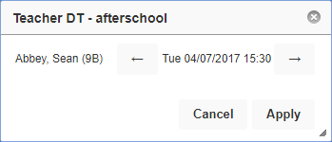

You can move the date of the detention by using the forward and backward arrows.

Note – if you do not click the Ready link, PARS will use the first available date for the detention when you click Save.

When you are happy with the detention, click the Save button at the top right of the page. A report will open in a new tab on your browser showing the date and time that the detention(s) will take place.

