View a Pupil’s Contact History

All messages sent from PARS to a pupil or their parents are stored in the pupil’s contact history. There are three methods to access a pupil’s contact history, which are covered in this guide.

Via the External Contact Page
This method can only be used to view one student’s contact history at a time. This is the only method that allows entries on the contact history to be edited or deleted. Go to:
Main menu > Contact management > External contact

A student selector window will open. Select the student(s) whose contact history you wish to view then click Accept. This will open the External Contact page.

Each of the selected pupils will be displayed on the left of the page. Click on the pupil whose contact history you wish to view then click the Contact history button on the top toolbar.
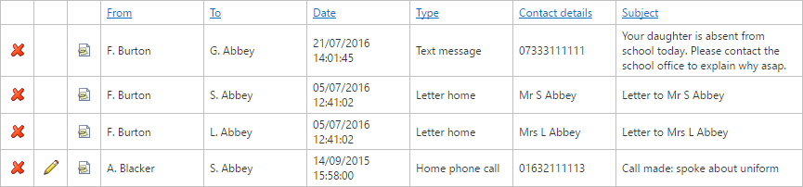

Entries on the contact history can be edited using the red cross buttons. Details of phone calls can be edited using the pencil buttons.

Using Contact Reports
Contact reports can show the contact history for multiple pupils in one single report. Reports can also be exported to PDF or Excel if required. To access the report go to:
Main menu > Contact management > Contact reports

The report is accessed via:
External contacts > Contact history

A date selector will open; select the date range of contact information that you require then click Accept. A student selector window will open. Select the student(s) whose contact history you wish to view then click Accept.

Using Behaviour Reports
There is a behaviour report that will show a student’s contact history, along with information about their behaviour incidents, detentions and times they have been on report. Reports can show the contact history for multiple pupils in one single report and can also be exported to PDF or Excel if required. To access this report go to:
Main menu > Behaviour > Behaviour reports

The report is accessed via:
Behaviour displays > Behaviour chronology

A date selector will open; select the date range of contact information that you require then click Accept. A student selector window will open. Select the student(s) whose contact history you wish to view then click Accept.

