Send a Message to All Teachers of a Pupil

PARS can be used to send messages staff, parents or pupils. This guide explains how to send a PARS notice (which can also be sent as an email or SMS message) to all of the teachers of a single pupil.

First go to the PARS home page. This can be accessed by clicking the house button at the top left of PARS.

Next you need to click the Notices button on the left side of the page.
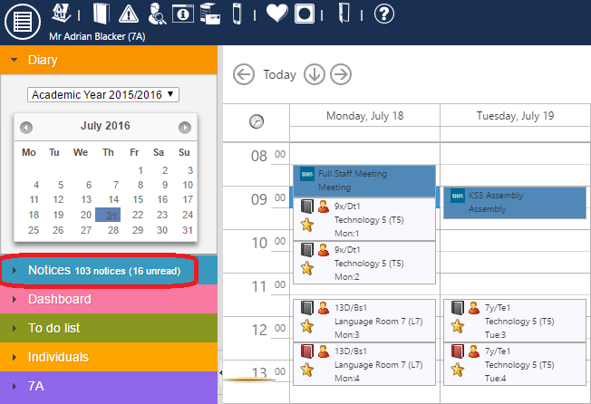

This will open the Notices page. Click the Compose button at the top left of the page. This will open a window where you can compose your message.

Type the title of the message in the Precis field and the actual message in the Notice field. If your message needs to include any files, click on the Attachments tab to upload the files.

Next click on the Recipients tab. Click the All teachers of button and a student selector window will appear. Select a student then click Accept. A list of the teachers of that pupil will then be added to the recipient list.
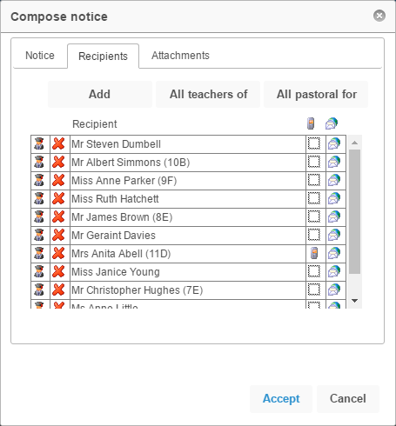

The message will always be sent as a PARS notice, which can be accessed via the Notices page. The message can also be sent as an email or SMS message.

There are columns to the right of the staff members’ names, one with a phone icon and the other with globe icon above. If a there is an icon in the phone column next to a staff member’s name then they will receive the message as an SMS. If there is an icon in the globe column, the staff member will receive an email.

Click next to a staff member’s name in either column if you want to toggle whether or not they receive an SMS or email. You can also click the column header to toggle all recipients.

Staff members can only receive emails or SMS messages if they have valid email addresses or mobile telephone numbers in SIMS. Icons will not appear next to staff if they do not have valid contact details.

You can repeat the step above, but using the All pastoral for button to include all of the pastoral staff linked to a student as recipients. This would include the Head of Year, Registration Tutor, etc.

Once you are happy with your message, click Accept to send.

