Create a Message Bank

When sending messages in PARS, the message to be sent can either be typed by hand or selected from a message bank. The message bank must be configured before this can be done. This guide explains how to configure the message bank.

There are three messages banks each for different types of messages; emails, letters and SMS messages. To access the banks go to:
Main menu > Configure > … message bank

All three of the message banks work in the same way, although there are fewer options for customisation in the SMS message bank (text size, colours, images, etc. cannot be used with SMS messages).

Click the Add button on the top toolbar to create a new message. This will open a window where you can configure you message. The title entered will be used by users when they are selecting the message. The actual message should be entered into the textbox at the bottom of the window.

Mail merge fields can be inserted into the message and can be related various aspects of PARS such as attendance, behaviour and detentions. To insert mail merge fields click Insert > Field.

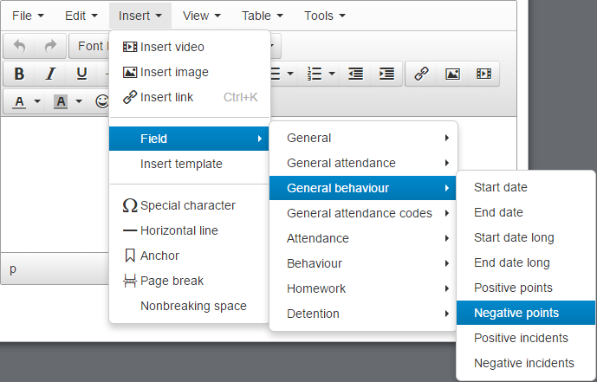

Mail merge fields are broken down into various different sections. Including fields from certain sections will limit the occasions on which the message can be used e.g. if you include a field from the Detention section then the message will only be available to users if they use a detention page to access the External Contact page.

