Contact Parents

Prerequisite Knowledge
When sending messages to parents you can either type your message by hand or select a pre-defined message from the message bank. This guide does not cover the process for creating pre-defined messages in the message bank (although this is not required if you want to type your message by hand). For information about creating pre-defined messages, see the Create a message bank guide.

Contacting Parents
To send messages to parents go to:
Main menu > Contact management > External contact

A student selector window will open. Select the pupils whose parents you want to contact then click Accept.

Parents can be contacted by email, SMS, letter or telephone call. There is a slightly different process for recording telephone calls than the other methods of contact. All are explained below.

Recording Telephone Calls
Each of the pupils will be listed on the left of the page, and one pupil’s details will be shown on the right. Click on a pupil’s name from the left side of the page to load their contact details.

Once you have loaded a student’s details, use the right side of the page to find one of their contacts’ phone numbers. Click the Call button next to the phone number you are going to use.

This will open a window where you can type the details of your phone call. PARS knows who you are, which student you are contacting, which parent you are contacting, what day it is and what time it is. All of this information is recorded automatically so you only need to type the details of the phone call.
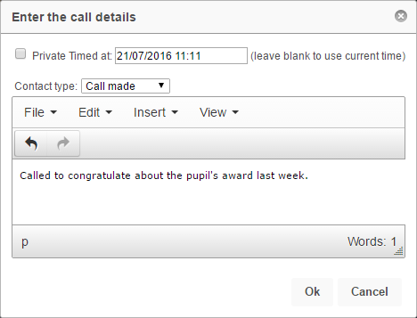

At the top of the window there is a dropdown box. You can use this to record whether the call was made successfully, there was not answer, a voicemail was left, etc. Once you have finished typing the details of the phone call click the OK button and the information will be saved to the pupil’s contact log.

Email, SMS and Letter
To send these types of message click the Generate batch button at the top left of the page. This opens a wizard to send messages to the parents of all pupils at once.

You will see a page with three tabs at the top right. On the first tab you need to select the types of parents you want to contact:
Recipient option in PARS | Who will be contacted
Student | Students
Priority 1 contact with Parental responsibility | Contacts who are both priority 1 and have parental responsibility
Priority 1 contact regardless of Parental responsibility | Contacts who are priority 1
All contacts with Parental responsibility | Contacts with parental responsibility

Select one options from the recipients list; this is the type of person who will be contacted (as shown above).

Next select the method you want to use from the Method section. If you select one of the falling back options, then the second type of communication will only be used if the recipient cannot be contacted using the first type.

E.g. Email falling back to SMS. SMS will only be used if the recipient does not have a valid email address.

When you are happy with the options selected, click on the Stage 2: Identify tab at the top of the window.

The Stage 2 tab will check that all pupils have at least one contact who can contacted by PARS. Any pupils who cannot be contacted will be highlighted in red. You can either:
- Continue, knowing that the pupils highlighted in red will not be contacted
- Login to SIMS and change their contact details so that somebody can be contacted using the rules selected in PARS
- Go back to the Stage 1 tab in PARS to change the options for recipients

Once you are happy with information shown, click on the Stage 3: Documents tab. Each method of contact will be shown and there will be a button underneath each section type of contact for which a message is going to be sent.

Click the button(s) to configure your message. A window will open where you can type your message. You can include mail merge fields by clicking Insert > Field. Alternatively you can select from a list of pre-defined messages by clicking Insert > Template.

Note that PARS does not come with any pre-defined messages. These need to be created by your school in the message bank which is accessed via:
Main menu > Contact management > Configure > … message bank

Once you are ready to send your messages, click the Generate button at the top left of the page. Emails and SMS messages will be sent instantly. If you are sending letters, a window will appear with a Collect link. Click the link to download your letters.

