Setup Notifications for Behaviour

PARS can automatically send messages to staff members when behaviour incidents are recorded. This guide explains how to create behaviour alerts, which should be used when you want to send information about behaviour to staff for information only. If staff are expected to take action on the back of the information they are receiving, you should use behaviour referrals instead. The Setup behaviour referrals guide explains how to use behaviour referrals.

Alerts can be configured to only send when a pupil accumulates a certain number of behaviour incidents e.g. 3 negative behaviour incidents in a week.

Creating an Alert
Behaviour alerts are created and managed on the following page:
Main menu > Behaviour > Configure > Configure alerts

Click the Add button at the top left of the page to create a new alert. A window will open with 3 tabs.

Recipients Tab
This tab is used to choose the recipients for the alert. Use the dropdown to select a type of staff member and click Add to add them to the list of recipients. PARS will send the behaviour alert to the correct staff member, depending on which student receives the behaviour incidents e.g. if “Registration tutor” is the recipient, then PARS will send the alert to the tutor of the child when the behaviour incident(s) are recorded.

Aside from Head of Subject and Head of Faculty, PARS use the SIMS pastoral structure to work out which staff members to send behaviour incidents to. Head of Subject and Head of Faculty are defined on the Subject Leaders page in PARS.

Triggers Tab
Here you should choose the types of behaviour incident that are going to trigger the alert to be sent. For example, if your alert is supposed to trigger when a pupil receives 3 negative incidents in a week, then you would choose All negative grounds. If you are only interested in certain behaviour incidents then just select the relevant grounds/outcomes from the list.

If you leave the outcome list blank then the alert will trigger when a pupil receives a behaviour incident with one of the selected grounds, regardless of the outcome. The same applies if you select outcomes and leave the grounds list empty.

If you select from both the outcome and grounds list, then the alert will only trigger if a pupil receives a behaviour incident with both one of the selected grounds and one of the selected outcomes.

Timespan Tab
There are four options on this tab. The first option determines how many behaviour incidents a student must receive before the alert is triggered.

The second option is the timeframe. A student must receive the number of behaviour incidents within this timeframe in order for the alert to be triggered.

If the In the same subject option is selected then an alert will only be triggered if a pupil receives enough behaviour incidents all within the same subject. This is usually used to trigger alerts to Heads of Subject.

The final setting determines the maximum number of messages that PARS will send, within the time period. Typically you should set this to a high number (such as 100) so that PARS does not stop sending messages.

Sending Alerts as Emails

The behaviour alerts will always be sent as PARS notices, which can be accessed via the Notices section on the Home Page.

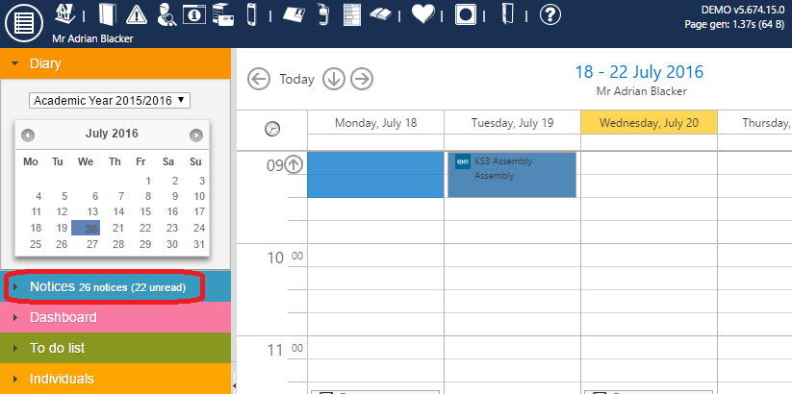

Behaviour alerts can also be sent as emails. To configure this go to:
Main menu > System management > Preferences

In the Notices section enable the Send an email where possible when sending all notices option. This will force all PARS notices to also send as emails.

Next go to the Email section and ensure that the correct SMTP details have been entered. Click the Send test email link to make sure that PARS is able to send emails.

Staff email addresses will also need to be listed in SIMS.

