Setup Behaviour Referrals

Behaviour referrals are used to send a single behaviour incident to another member of staff. Referrals should only be used if the recipient is expected to take further action such as adding a detention or changing the outcome of the behaviour incident.

If you want to send alerts to staff about behaviour incidents for information only, see the Setup notifications for behaviour guide.

Recipients for behaviour referrals are shown on the Referrals tab when adding a behaviour incident.
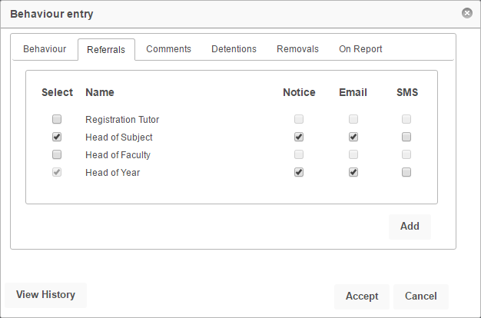

PARS can be configured so that referrals can be selected by staff at their own discretion, or only when certain behaviour incidents are added.

Adding Staff to the Referral List

Go to Main menu > Behaviour > Configure > Behaviour referrals

This is the page used to configure behaviour referrals. Click the Add staff type button to add a new type of staff member. There are various types, such as Registration Tutor.

When referrals are sent to types of staff, PARS will work out who the correct staff member is based on the Pastoral Structure in SIMS, unless the recipient is Head of Subject or Head of Faculty. These staff are taken from PARS via: Main menu > System management > Subject leaders.

You can also add specific staff members using the Add button. This will open a window where you can select staff members.

By default there will be two types of staff on the referral list that cannot be deleted; Form supervisor and All teachers of selected pupil (s). The Form supervisor is not the registration tutor, it is a Supervisor, Pastoral Manager or Joint Main Supervisor from the Pastoral Structure.

Staff can be hidden from the referral list by selecting them using the circular buttons on the left of the page then click the Edit button. Select the Only the people shown below see this person by default option to hide the staff member.
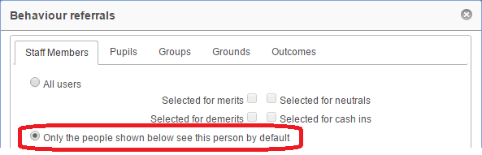

Automatic Referrals
Referrals can be automatically send for certain behaviour incidents. First, using the circular buttons on the left of the page, select the staff member or type who should automatically receive behaviour referrals. Next click the Edit button.

Click on the Grounds or Outcomes tab at the top of the window and select any grounds or outcomes for which you want referrals to be sent automatically. Whenever a behaviour incident is added using one of these grounds/outcomes, the staff member will automatically be selected on the referral list (and cannot be deselected). This will happen even if the staff member has been hidden from the referral list (see previous page for details about hiding staff from the referral list).

Receiving Behaviour Referrals

Behaviour referrals will always be visible on the following page:
Main menu > Behaviour > Referrals > Collect behaviour referrals

Referrals may also be sent as Notices or via email. Notices can be accessed via the Notices section on the Home Page.
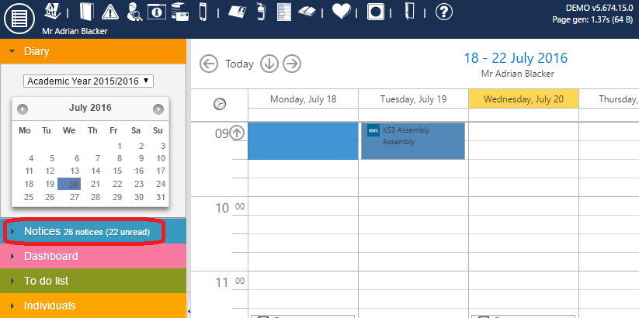

To configure PARS so that referrals are also sent as emails, go to:
Main menu > System management > Preferences

In the Notices section enable the Send an email where possible when sending all notices option. This will force all PARS notices to also send as emails.

Next go to the Email section and ensure that the correct SMTP details have been entered. Click the Send test email link to make sure that PARS is able to send emails.

Staff email addresses will also need to be listed in SIMS.

