Run a Behaviour Report

This guide will explain how to run a single behaviour report. Reporting features such as hiding columns, filtering data and automating the report will be covered.

This guide uses a single report for demonstration purposes and does not offer guidance as to which behaviour reports should be used for various purposes. See the Suggested behaviour reports guide for a list of useful behaviour reports.

Running the Behaviour Report
To access behaviour reports go to:
Main menu > Behaviour > Behaviour reports

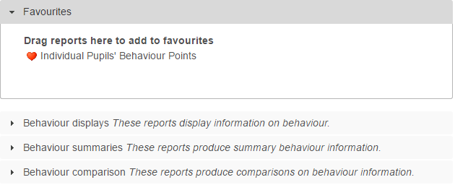

Click on Behaviour comparison to expand the section then from the Individual section, click on the top left report, Comparison.

A date selector window will now appear. At the bottom left of the window there is a list of vulnerability groupings that you can choose to show on your report. Select any of the groupings you want on your report.

Next choose the date range. Click the Year to Date link on the left of the window, then click Accept.

A student selection window will now open. Select a year group of students by clicking the Year groups section on the left of the window, then using the checkboxes to select a year group.

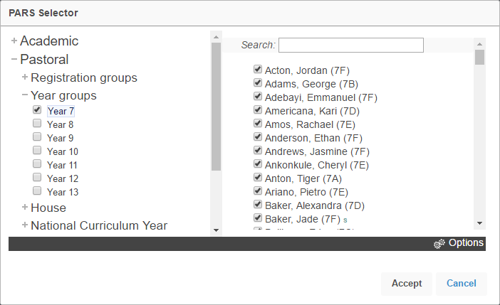

Your report will then open in a new window.
If your report does not open, check that your pop-up blocker has not blocked pop-ups from PARS.
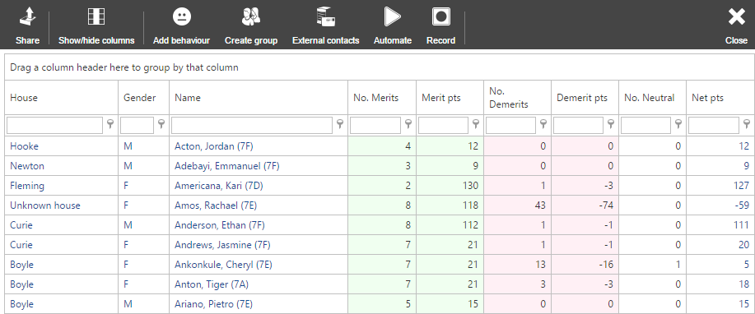

Features in Reports

Hiding Columns
To hide columns from your report, click the Show/hide columns button on the top toolbar. This will open a window with a list of all of the columns that are available on the report. Deselect any columns you wish to hide.

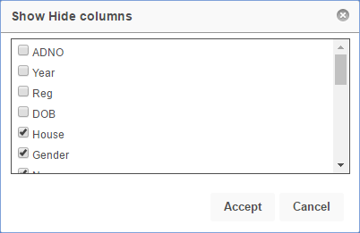

Ordering Data

To order the data on the report (e.g. highest to lowest) click on the column header for the column you want to order. Click the column header once to order lowest to highest, or twice to order highest to lowest.

In the report in our example, click the Merit pts column header twice to order highest to lowest based on the number of positive points. The pupils with the most positive points will appear at the top of the report.

Filtering

The data in the report can be filtered e.g. pupils with zero negative incidents. To do this, first select the column you are going to filter. The No demerits column shows the pupils’ negative incident count.

Beneath the column header there is a textbox and a button that looks like a pin.

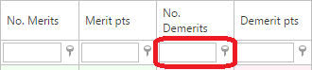

Click on the pin button to see the options for filtering. For this example, select Is less than. Next type the number you want to use for filtering into the textbox, in this case type 1.

The report will now only show pupils with zero negative incidents.

Automating the Report

In PARS reports can be automated. This means the report will automatically be emailed to one or more email addresses, once or more a week. Filters can be applied to automated reports, data can be ordered and columns can be hidden.

First configure the report so that it looks exactly as you want it e.g. apply filters, hide columns, etc.

Next click the Automate button on the top toolbar. This will open a window with various options for automating your report.

Your automated report will need a job name. It is recommended that you start with your initials, as this will make it easier to identify your own reports from the list of all automated reports in the future.

Choose a timeframe for your report. This is the date range that the report will use when it is sent. Enter one or more email addresses to receive the report, separated by semi colons. You can also click the button next to the email textbox to select staff members. PARS will then find their email addresses for you.

Choose the format that you would like the report to use. XSL and XSLX are both Excel documents. XSLX is slightly more modern than XSL.

Finally choose the day(s) and time you would like the report to be sent. Once done, click the Automate button. Your report will then be added to the automation list.

