Automatic Behaviour Points

PARS can automatically award behaviour points to pupils when they hit certain criteria e.g. a bonus point for 0 demerits in a week, or a negative behaviour point for arriving late 3 times in a week.

This guide will explain the features available when creating automatic behaviour points, and then give examples of common setups.

To setup automatic behaviour points go to:
Main menu > Behaviour > Rule based behaviours

Creating a Behaviour Rule

Each rule decides what criteria the pupils must trigger to receive a behaviour incident, and what behaviour incident will be given to them. Click the Add button to create a new rule.

Rule Tab
The Rules tab is used to set the criteria that pupils must trigger in order to receive a behaviour incident. Enter a name for the rule in the Description field. This could be something like “3x late in a week”.

In the middle of the window there is a Type section. This is what a pupil must do in order to trigger the rule and have a behaviour incident issued to them. A rule to award a bonus where pupils have no demerits in a week would use "Demerit count", as it is the number of demerits that a pupil has, that affects whether or not they will trigger the rule. Likewise a rule to penalise pupils for arriving more than 5 minutes late to lesson would use "Lesson lates - minutes", as it is the number of minutes that a pupil is late that decides whether or not the rule will issue behaviour incidents.

At the top of the window there are Criteria and Operator fields. They define how often/how many times a pupil must do the activity specified in Type (above) in order to trigger the rule.

There are three types of operator:
At This means At Least. If a pupil performs at least a certain number of actions, or achieves at least a certain attendance percentage, then they will trigger the rule.
Below This means Less Than. A pupil will trigger the rule if they have performed less than a certain number of actions, or have less than a certain attendance percentage.
Every This means that every time a pupil performs a certain number of actions, they will trigger the rule. This can result in multiple behaviour incidents being added. For example, imagine you have a rule configured to issue a negative incident every 5 minutes that a pupil is late. A pupil who is late by 15 minutes would receive 3 negative incidents.

At the bottom of the window you can set the Range field. This is the time period. A pupil must complete the activity specified in Type within this date range in order to trigger the rule.

Behaviour Tab
The Behaviour tab is used to choose the behaviour incident that will be given to pupils if they trigger the rule. You must choose the type of behaviour incident from the top of the window e.g. Merit, Demerit or Neutral.

Next you must choose a category, ground and outcome for the behaviour incident that will be given to pupils.
The Summarise option is only used for that that trigger every time a pupil does something i.e. every 5 minutes late. If the Summarise option is used then the rule will only issue one behaviour incident regardless of the number of times the rule has been triggered.

If the Summarise option was used with a rule that issues a behaviour incident for every five minutes that a pupil is late to lesson and a pupil was late 15 minutes, then the pupil would only receive one behaviour incident. If the behaviour incident would normally be worth -2 points, then the rule would give the pupil one behaviour incident worth -6 points as the pupil has triggered the rule 3 times. However only one behaviour incident would be added.

The Delete option is used to remove interim behaviour incidents. This is explained in the Examples section, below. The SIMS mirroring option is used to write the behaviour incidents back to SIMS.

Student Applicability
This tab is used to restrict the pupils that the rule applies to. Schools will commonly have different rules for 6th form. If this tab is blank then the rule will apply to all pupils in the school.

To restrict the pupils that the rule applies to, click the Add button then select the groups of pupils that the rule should apply to. Any groups not selected will not be affected by the rule.

Examples

1. We want PARS to issue one negative behaviour incident if pupils are late to school 3 or more times in a week.
If a student is late to school at least 3 times in a week, then issue a level 1 sanction, because of their punctuality.

2. We want PARS to issue a positive behaviour incident if pupils achieve 100% attendance in a term.
If a student has at least 100 percent attendance in a term, then issue a silver certificate, because of their attendance.

3. We want PARS to issue a negative behaviour incident whenever a pupil accumulates 30 minutes lateness to lessons, and another if they accumulate 60 minutes, and another for 90 minutes, etc.
For every 30 minutes late to lessons within the year, issue a level 2 sanction, because of punctuality.

4. We want PARS to issue a positive behaviour incident if pupils do not receive any negatives incidents in a week.
If a student gets less than 1 negative incident in a week, then issue a bronze certificate, because of their behaviour.
Key
Colour | Field
 | Operator
 | Criteria
 | Type
 | Range
 | Outcome
 | Ground

The fourth example is a special case; here a pupil will trigger the rule by NOT doing something i.e. not receiving any demerits. There is a different process when setting up rules that are triggered by pupils not doing something. See the explanation for the fourth example for further details.

Example 1

1. We want PARS to issue one negative behaviour incident if pupils are late to school 3 or more times in a week.
If a student is late to school at least 3 times in a week, then issue a level 1 sanction, because of their punctuality.

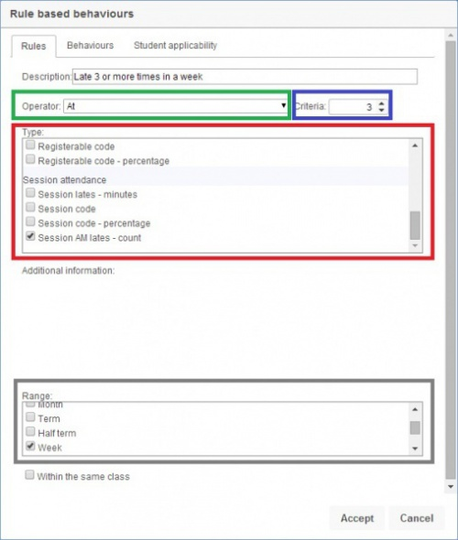

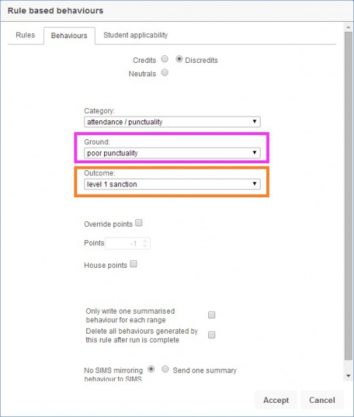

Example 2

2. We want PARS to issue a positive behaviour incident if pupils achieve 100% attendance in a term.
If a student has at least 100 percent attendance in a term, then issue a silver certificate, because of their attendance.
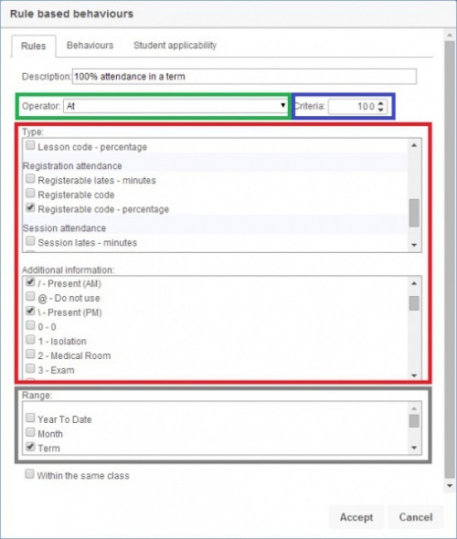

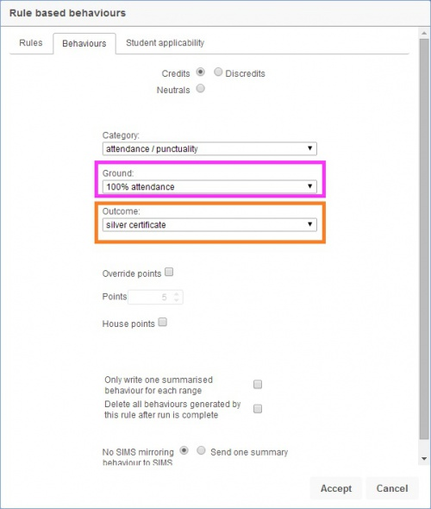

Example 3

3. We want PARS to issue a negative behaviour incident whenever a pupil accumulates 30 minutes lateness to lessons, and another if they accumulate 60 minutes, and another for 90 minutes, etc.
For every 30 minutes late to lessons within the year, issue a level 2 sanction, because of punctuality.
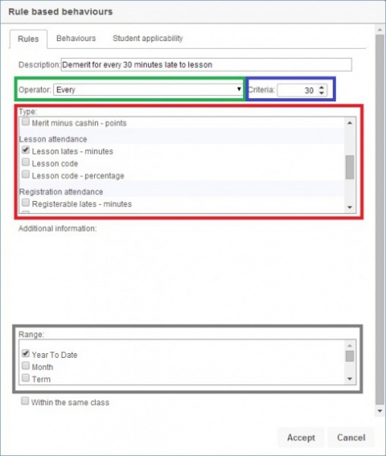

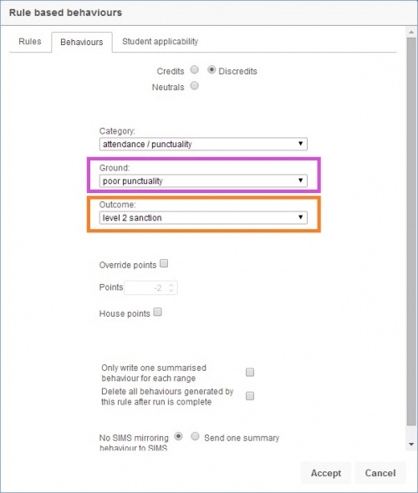

Example 4
There is an extra consideration to make when creating rules that trigger when pupils do not do something - pupils will always trigger this if they are absent!

4. We want PARS to issue a positive behaviour incident if pupils do not receive any negatives incidents in a week.
If a student gets less than 1 negative incident in a week, then issue a bronze certificate, because of their behaviour.

To make this work, you need to create 3 rules:
1) A rule that checks if pupils have received 0 demerits in a week
2) A rule that checks pupils have attended school in a week
3) A rule that checks if the two rules above have been triggered, and if so, awards a behaviour incident

If a student gets less than 1 negative incidents in a week, then issue an interim neutral incident, because of their behaviour.
If a student gets at least 60% attendance in a week, then issue an interim neutral incident, because of their attendance.
If a student gets at least 2 interim neutral incidents in a week, then issue a bronze certificate, because of their behaviour and attendance.

Interim neutral incidents are just neutral behaviour incidents that will be used by your rule based behaviours. These neutral incidents should never be used for anything else. To ensure that this is the case, you should create a new neutral incident (ground or outcome) and restrict usage so that general staff cannot use it.

When you are creating the rules that issue the interim neutral incidents (not for the rule that issues the positive behaviour incident at the end!) you should use the option in the "Deleting" section on the "Behaviour" tab. This will ensure that the interim neutral incidents are deleted, and pupils are only given their positive points.
