Add a Behaviour Incident via a Register

Prerequisite Knowledge
This training guide assumes that you know how to access and open a register. The Take a register guide covers this. Behaviour will also need to be configured in PARS before behaviour incidents can be added. The Create a new behaviour structure in PARS or the Import the behaviour structure from SIMS guides cover the configuration for behaviour in PARS.

Adding Behaviour Incidents
First you will need to open your register. In the register you will see a list of the pupils’ names. To the left of the names there are several additional columns. The column with the green face at the top is used to add positive behaviour incidents and the column with the red face is used for negative incidents.

Click next to a pupil’s name in the red face column to add a negative incident. This will open the behaviour entry window.
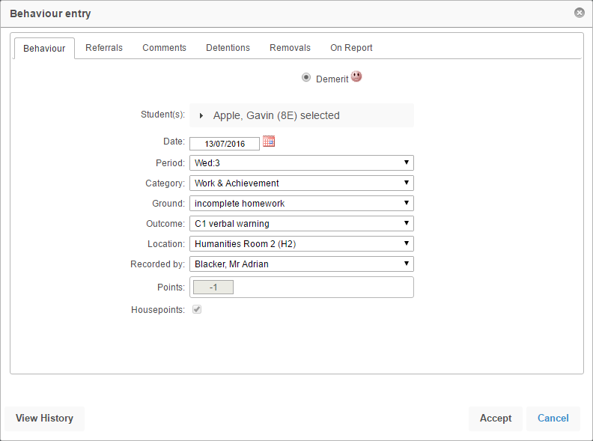

The selected pupil’s name will appear at the top of the window. If you want to add the same behaviour incident for multiple pupils at once, click on the pupil’s name at the top of the window.

This will expand and a list of all pupils in the class will be shown. Select all the pupils that you want to give the behaviour incident to.

Next select the Category. This is the area of behaviour you are dealing with e.g. Attendance & Punctuality, or Equipment & Uniform.

Now select the Ground. This is what the pupil has done. The list of grounds will change depending on the Category you selected. Next select the Outcome. This is what you are going to do in response to the pupils’ actions. The list of Outcomes may also change depending on the Category selected.
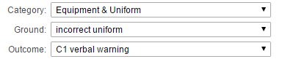

PARS will automatically fill in the date, period and room. When you save the behaviour incident PARS will work out which subject the incident is related to (based on the register you have open).

You may want to add further information regarding the behaviour incident. To do this, click on the Comments tab at the top of the window. Three textboxes will be available. Use the top textbox (Grounds comment) to record any additional information.

Once you have entered all of the information about the behaviour incident, click the Accept button at the bottom of the window to save the behaviour incident.

