Use Seating Plans

# Prerequisite Knowledge

This training guide assumes that a seating plan has already been created and that you know how to access a register. See the **Take a Register** or **Create a New Seating Plan** guides if you need any guidance.

# Using Seating Plans

This guide covers:

* How to assign pupils to seats
* How to move pupils after they have been seated
* How to view pupil information (pupil premium, SEN, etc.)
* How to export the seating plan
* How to use the heat map

## Assign Pupils to Seats

Open the register for the class you want to deal with, then click the **Seating** button at the top left of the register to open the seating plan. You should see several chairs, each of which will have a blue and white cross button.

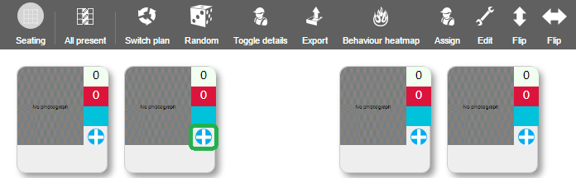

This button is used if you want to place pupils into their seats one by one (the alternative is to have PARS assign pupils to seats for you). Once you have clicked the blue and white button, more buttons will appear.

Click the green plus button and a small window with a drop-down menu will appear. Click on the drop down to select a pupil to assign to the seat. Only pupils who are in this class and who have not already been assigned to a seat will appear in the drop down. Once you have selected a pupil, click **Assign**. Repeat this process until every pupil has a seat.

Alternatively, PARS can automatically seat all of the pupils for you. To do this click the **Assign** button on the top toolbar. This will open a window with several options.

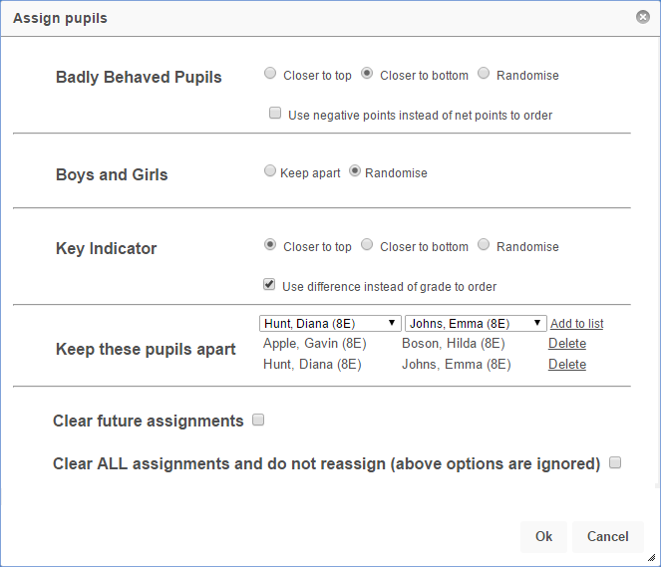

By default, the behaviour options will look at the pupils’ net points, which is the balance between their positive and negative behaviour points. Use the **Use negative points instead of net points** option if you do not want to use net points. The behaviour points are calculated by looking at the pupils’ behaviour in every class for the whole year, not just for your class.

If you wish to separate two pupils, select both pupils’ names and click the **Add to list** link. This can be done multiple times if there are several sets of pupils that you do not want sitting together.

The Key Indicator section of the window looks at pupils’ assessment data. If you select **Closer to the top** then the pupils with the highest grades will be position at the top of the seating plan. Use the **Use difference instead of grade order** option if you want pupils who are furthest above their target to sit at the top/bottom of the seating plan.

## Move pupils after they have been seated

The swap seats button is used to move pupils after they have been assigned to a seat. Click the blue and white options button on a chair and more buttons will appear.

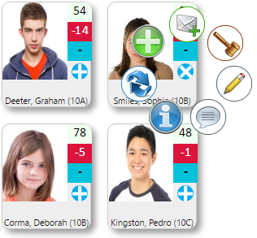

Select the **Swap seats** button (two arrows pointing at each other) then click on the photo section of the chair you want to move the pupil to.

## How to view pupil information

Click the **Toggle details** button on the top toolbar to see additional information about the pupils in the class. The pupils’ photographs will shrink and bubbles will appear beneath the photograph if there is additional information about the pupil. Hover over the bubble to see what it means.

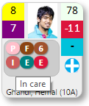

A yellow and a purple box will appear to the left of the pupil’s photograph. The yellow bow will show the pupil’s current grade and the purple box shows the target grade.

*A key indicator template must be configured in order for grades to display. See the* ***Create a Key Indicator*** *guide for more information.*

## Exporting the Seating Plan

Use the **Export** button on the top toolbar to download an image showing the seating plan. This image can then be saved, emailed or printed as required.

## Generating a Heat Map

Click the **Behaviour heatmap** button on the top toolbar to generate a heat map for the class. Select one of the three options and PARS will set the background of the seating plan to blue, which will fade into green, orange and red towards the pupils with the worst behaviour.

The heat map uses behaviour points from all subjects year-to-date, not just from your class.