Update Attendance (Attendance Officers)

There is a page in PARS called Attendance View which is used to manage and update the attendance of pupils. This page allows the user to overwrite any attendance marks and therefore should only be used by attendance officers and other admin staff, not by general teaching staff.

Loading Attendance

To access the attendance view page, go to:
Main menu > Attendance > Attendance view

A student selector window will then appear. Select the students whose attendance you want to deal with. Typically schools will either select one year group or the whole school.

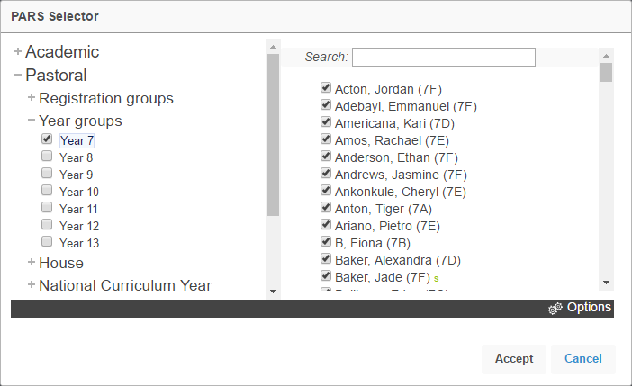

Next you need to select a date range for the attendance. PARS will default to today, but you can change the date range by clicking the links on the left of the window or by selecting a start and end date from the calendars.
Note that a maximum of one week can be shown if you are dealing with multiple pupils.

Click OK when you have selected a date range and PARS will load the attendance for the pupils you selected.

Mark Protection

When you first come to the Attendance View page, mark protection will be enabled. This means you cannot overwrite any attendance marks. To turn this off click the Protection button on the top toolbar. Select the No protection option; this will let you overwrite anything. You can change the level of protection more quickly by pressing the escape button on your keyboard (top left). The Protection button on the top toolbar will change every time you press escape.

Finding Pupils

To find a specific pupil, type either their forename or surname into the search bar at the top left of the window.
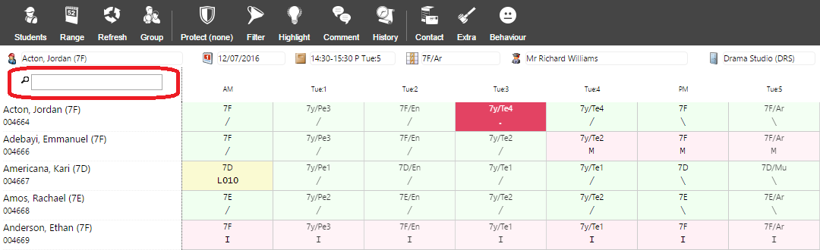

You can also scroll up and down the list of pupils, who will appear in alphabetical order. The order of the pupils cannot be changed.

The Attendance View page can also be filtered to show only pupils for certain attendance codes e.g. only pupils with N codes. To do this click the Filter button on the top toolbar. This will open a new window. Select the Pupils who have not attended school today with no reason ‘N’ option then click OK. Only pupils who have been absent all day (at least one N code and no present marks) will be shown on screen.

Updating Attendance

Once you have found the pupils, you need to select the period(s) of attendance that you want to update. This works in a similar way to an Excel spreadsheet:

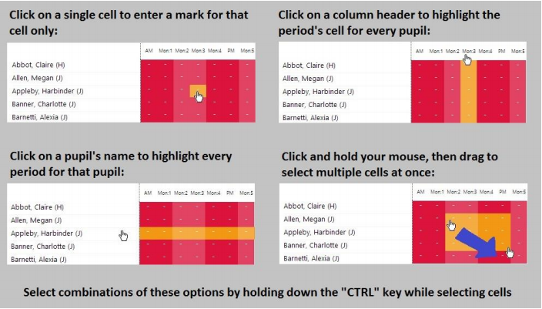

Now you need to select the attendance codes that you want to insert. You can either right on one of the selected cells to see a list of all available attendance codes, or simply press the button on your keyboard that corresponds to the code that you want to use.

The Attendance View page does not automatically save data so you must click Save before you leave the page, otherwise your work will be lost. The Save button is located at the top right of the page (and will not be visible until a change has been made to attendance).

