Take Fire Registers

PARS has a specific system for fire registers. This is an alternative to printing an attendance list after the AM registers have been taken and keeping a signing in/out book at reception.

The PARS fire module will update itself with the whole school’s attendance every five minutes. This includes extra class and detention registers so PARS can identify the pupils who are present or absent at any point in the day, including after lessons have finished.

The fire module should run on one or more tablets that can be taken outside in the event of a fire. The tablets should permanently left on charge and set to never go on standby. These tablets do not need a lot of processing power; you can use some of the cheapest on the market for this purpose.

On the tablets that are going to be used for fire registers, log in to PARS and go to:
Main menu > System management > Fire

Click on the View live attendance information online link to open the list of registers for the day. A number will be displayed at the top right of the page that counts down from 300. This is the number of seconds until the fire module refreshes the attendance data that it is showing.

The Process in Case of a Fire

Each registration tutor should have a blank paper register that they can use to register the pupils outside. Once each tutor has taken their register, they can go to one of the staff members who has a tablet running the fire module.

The fire module will show a list of all the pupils in the school. Click the dropdown beneath the Reg column to filter the page.
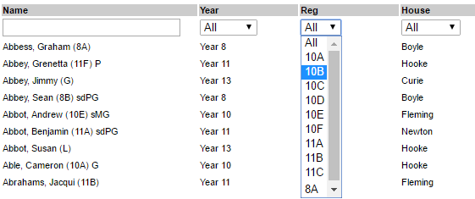

Once the page has been filtered, cross reference the information shown on the fire module with the paper register the form tutor has taken.
