Taking a Register

When you log in to PARS Connect, the first thing you will see is your diary.
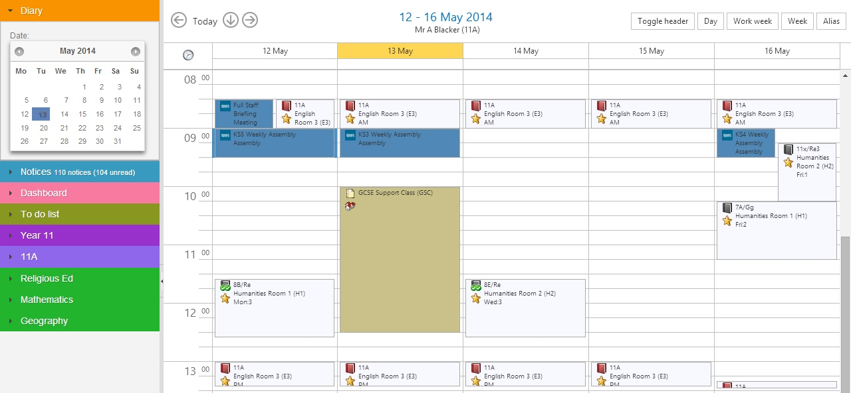

By default your calendar will show you your events for this week, Monday to Friday. You will see any lessons that you have, as well as extra classes, detentions and SIMS events.

Your lessons will be colour-coded, depending on whether you are covering them, and whether the register has statutory marks.

 | Not covering | Covering
Not statutory  (academic lesson) | 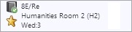 | 
Statutory  (usually form group) | 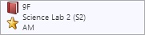 | 

Click on a register to open it.

You can see attendance data for the whole day.

The current period (3) is highlighted.
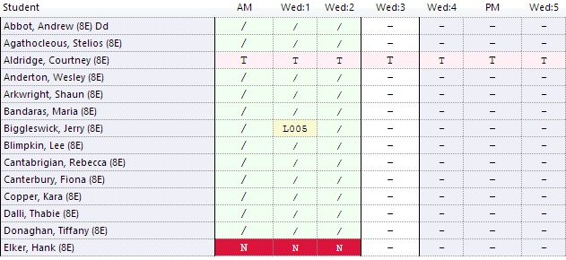

You can enter marks for pupils by click the buttons on your keyboard. Use N to mark a pupil absent, slash (/ or \) to mark a pupil present, and L to mark them late. If you mark a pupil late, you will also need to enter how many minutes late they were.

You can also left-click in the column for this register (for example, Wed:3 in the screenshot above) to see a list of the attendance codes that are available to you.
Single click on the attendance code that you want to use.
You may have access to different attendance codes, depending on your permissions.
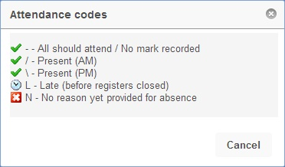

You can also click on a pupil’s name in the register to change their attendance mark. When you have completed your register, buttons will appear at the top-right allowing you to save. You will not be able to save your register until you have entered marks for ALL pupils.

Click “Save” to save the register but keep it open, or “Save+Close” to save the register and return to your diary.
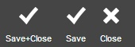

Alternative Methods to Access Registers

Via a teacher’s timetable

You can view other staff members’ timetables and access their registers. To do this you must go back to the homepage in PARS. Click the house button in the dark blue bar at the top of PARS.



The alias button is used to access other staff members’ timetables. The alias button appears at the top right of the timetable.
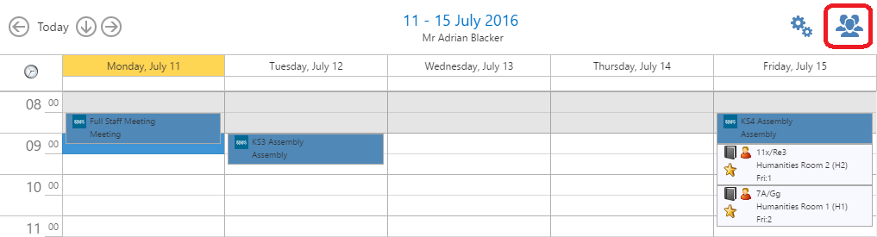

Clicking the alias button will open a window with a list of all staff members. Teachers are shown at the top of the list. Click on a teacher’s name to view their timetable. You will then be able to take their registers.

Via the take a register page

All of the day’s registers can be viewed on the Take a register page. This page is accessed via:
Main menu > Attendance > Take a register
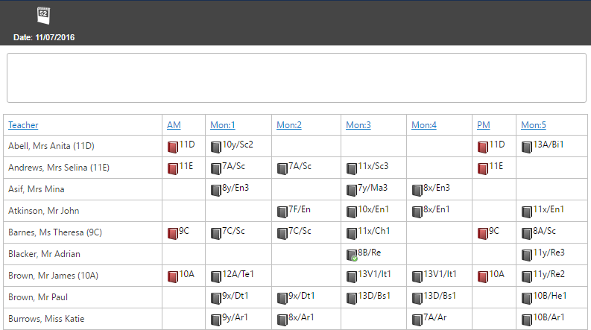

All of the day’s registers will be shown. By default the page will be ordered alphabetically by staff members’ surnames. You can order the page by class code by clicking on one of the column headers.

By default, today’s registers will be shown. You can change the date by clicking the date selector button at the top left of the page.

Once you have found the register you want to take, click on it to open it.

