Setup Automatic Alerts for Absentees or Truants

PARS can automatically send messages to staff when certain pupils are marked absent, or if they appear to be truanting (the pupil receives a present mark to their AM registers and an N code later during the day).

You should first make sure that attendance alerts are enabled. To do this go to:
Main menu > System management > Registration preferences

On the Operational preferences tab there is a setting called Enable Attendance based notice alerts. This must be turned Yes.

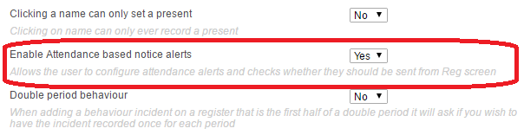

Next the alerts need to be configured. To setup the alerts go to:
Main menu > Group management > Group manager

Click PARS Special groups in the section on the left side of the page. This will expand to show more types of groups. Click on PARS notice recipient groups.

An Add button will now have appeared at the top left of the page. Click this to create a new group and called it “Attendance Alert” or something similar. Do not select any of the other options when creating the group and click Save when done.

Your Attendance Alert group will now be visible on the left side of the page. Click on the group and an Add button will appear in a section in the middle of the page.
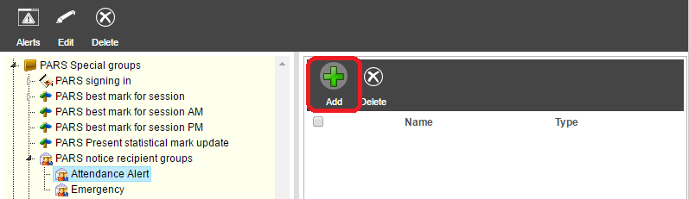

Click the Add button then select all of the pupils for whom you want to receive attendance alerts. Also select the staff members who need to receive the alerts. Click Accept once done.

Your group should still be highlighted on the left side of the Group management page, but if it is not, click on the group to highlight it. Now click the Alerts button at the top left of the page.
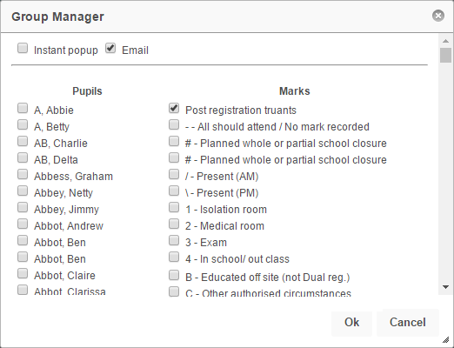
Select the codes that you want to be alerted about from the section on the right side of the window.

You can select the Email or Instant popup options from the top of the window if you want to receive notices in either/both formats.

Click OK when done.

