Recommended attendance reports

There are many attendance reports in PARS. Screenshots of each report can be found on our wiki page. This guide explains which attendance reports are used by schools for common tasks.

This training guide assumes that you know how to run attendance reports. If you do not, see the Run an attendance report guide.

First, go to the attendance reports page:
Main menu > Attendance > Attendance reports

Percentage Attendance for Individual Pupils

This report will show the percentage attendance for one or more pupils at a single point in time. The report is found via:
Attendance summaries > Individual percentages > Selected individual session attendance
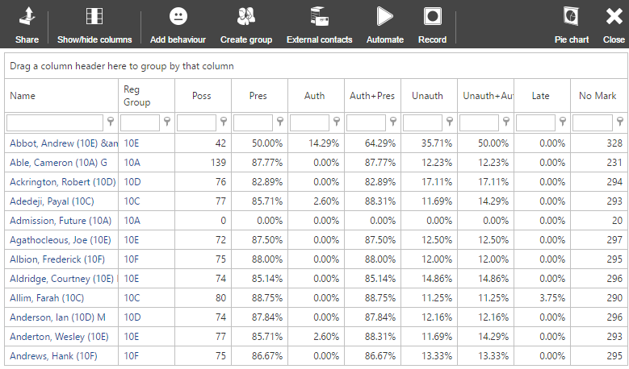

Percentage Attendance for Groups

This report will show the percentage attendance for an entire group, rather than for the pupils in that group. The report is found via:
Attendance summaries for groups > Percentages > Group attendance – session
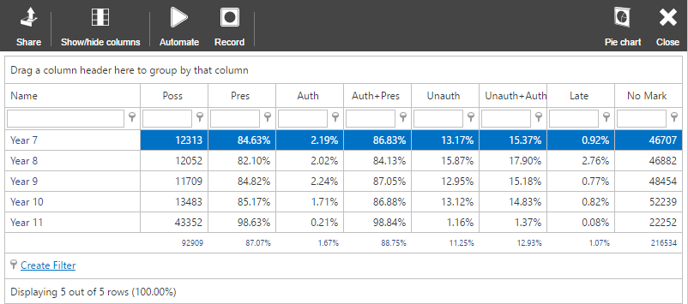

Persistent Absence

The persistent absence report is used to find all pupils whose attendance has fallen below a certain threshold at some point during a date range. The report will show the pupils’ attendance during each week during the date range so you can see whether pupils’ attendance is rising or falling. The report is found via:
Attendance summaries > Percentages > Persistent absences, year to date

When running this report it is recommended to not use the first 3 weeks of the school year. This is because it is very easy for a pupil’s attendance to fall sharply at the start of the year from only one or two absences.
Screenshot on next page.
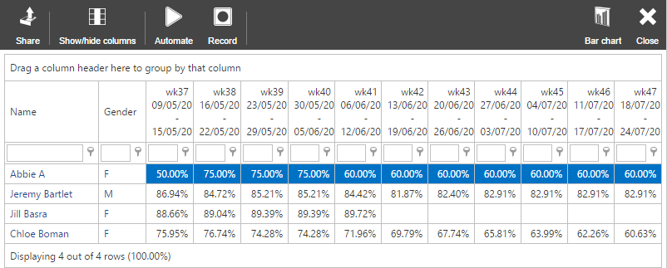

The report will show a blank cell if the pupil was above the persistent absence range during the week shown. A percentage attendance is shown if a pupil is below the persistent absence threshold. Each cell shows the pupil’s attendance, year to date, at that point in time.

Latecomers

This report shows a list of the times that a pupil has been late to school, as well as the number of minutes that they were late and the attendance comment (if applicable). The report is found via:
Attendance Miscellaneous > Latecomers > Latecomers into school – minutes late with comments
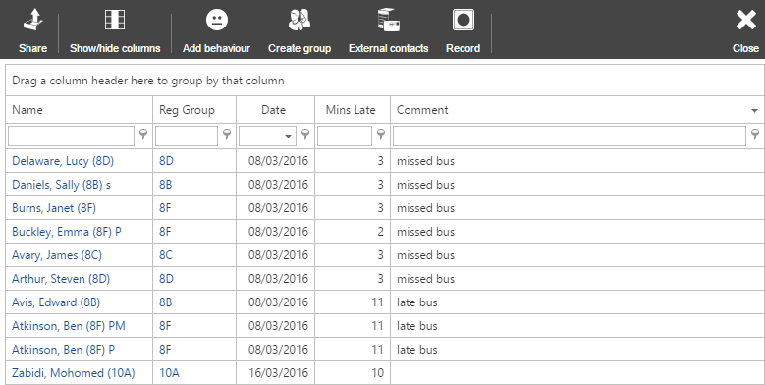

List of N Codes

This report will show a list of the dates that pupils have received N codes in their attendance to AM or PM registers. The report is found via:
Attendance miscellaneous > Missing reasons > Missing reasons – sessions

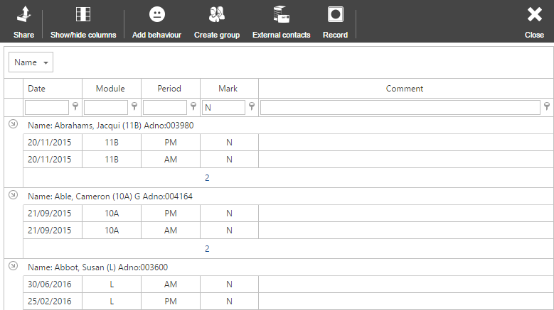

By default this report will also show missing marks. Type the letter “N” into the textbox beneath the Mark column header to filter the report to only show N codes.

Registration Certificates

If required, registration certificates can be produced in PARS. The report used for this is:
Attendance displays > Registration certificates > Session only

