Generate Letters for Absence to Sessions
First you should create a template for the letter which can be reused in future. To do this go to:
Main menu > Contact management > Configure > Letter message bank

Click the Add button at the top of the page to create your letter template. Enter “Session absences” as the title of the letter.

Now type your letter into the window. You can include mail merge fields by clicking Insert > Field. Click on the merge fields you want to include in your letter. Images (such as the school letter head) can be included by clicking Insert > Insert image.

Below is an example of a template:
{ADDRESS_BLOCK}
{TODAYS_DATE}

Dear {SALUTATION}

Your {SON_DAUGHTER}, {FORENAME} {SURNAME} has unexplained absences on the following dates:

{S_CODEDATESAMPM_N}

Please contact the school with reasons for {FORENAME}'s absence. You must provide a reason within two weeks of your child's absence.

Regards
School

Once you have created your letter template, you need to identify the pupils with N codes in their AM/PM registers then send a message to their contacts.

To identify the pupils, go to Main menu > Attendance > Attendance reports. Click on the Attendance Miscellaneous section, then click on the report called Missing reasons – Sessions.

Note – you may want to ‘favourite’ this report so it is easier to find in the future. To do this, click and hold your mouse on the name of the report, then drag it to the favourites section at the top of the page and release the mouse button. The report will then always appear in the favourites section whenever you come to the Attendance reports page. You can also rename favourited reports by clicking on the heart icon next to their name.
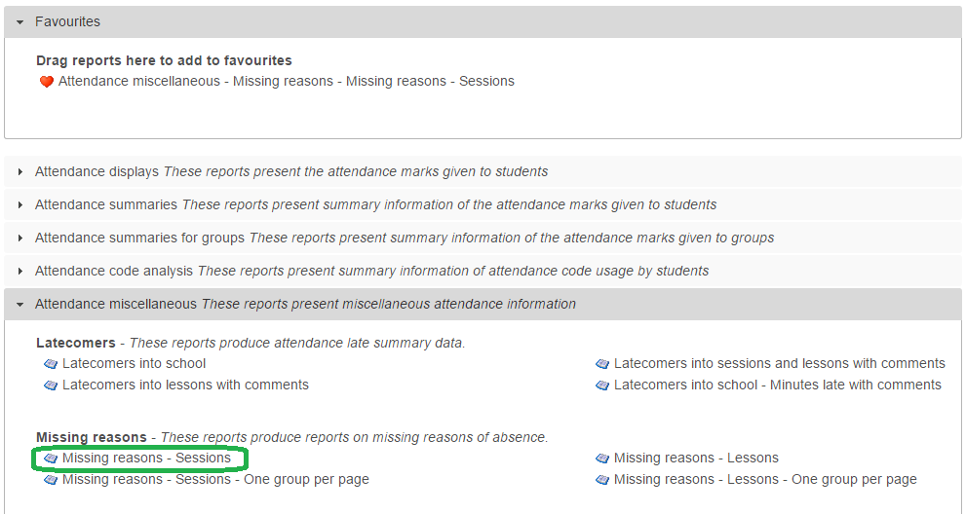

Once you have clicked on the name of the report, a window will open for you to select a date range. You can either click on the date ranges on the left side of the window, or enter a manual date range on the right hand side.

Once you have selected your date range, the window will change so that you can choose pupils. If you want to find the N codes for all pupils, click the “All Tiers” checkbox on the left of the window. Alternatively, you could select pupils from specific year groups by clicking “Year groups” then selecting one or more year groups.
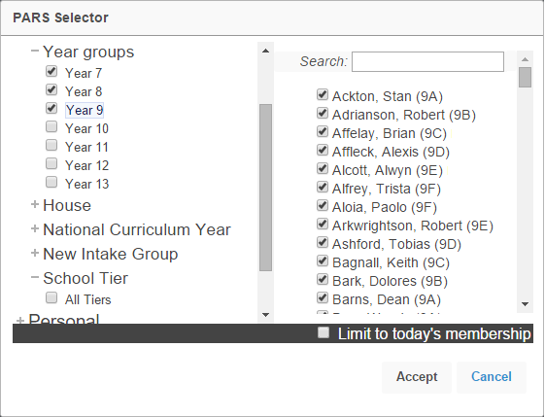

Once you have selected the pupils, click the Accept button at the bottom of the window. The report will then generate.

The report now needs to be filtered to only show N codes. To do this, type the letter N into the text box beneath the Mark column header.
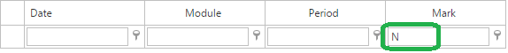

You now have a list of the pupils with N codes for AM/PM. The next step is to generate letters for these pupils. Click the External contacts button at the top of the report and you will be taken to a new page.

Click the Generate batch button at the top left of the page. There are now three steps to sending your message.

Stage 1: Recipients

This section is split into three parts. On the left side of the page you can deselect any students if you do not want to send a letter to their contacts. In the middle of the page, select the recipients that you would like to send the letter to. On the right of the page, select Letter.

Next click on the Stage 2 tab.

Stage 2: Identify

PARS will now load a summary showing which parents are going to receive letters. If any students do not have a contact that can be reached using the options you selected on the previous tab, the student’s name will be highlighted in red.

Next to each contact’s name, you will see superscript text ^{like this}. The number is the contact’s priority level, and a P will be shown if the contact has Parental Responsibility.

Stage 3: Documents

Click the button underneath Letter and a window will open. In the window, click Insert > Insert template.
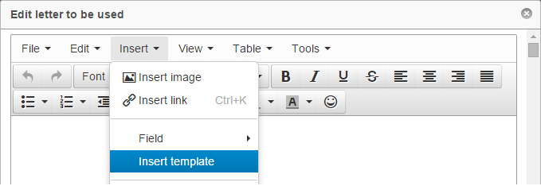

A new window will open. Choose your pre-configured message from the dropdown list then click OK. Click Save in the following window.

If you want to upload a copy of the letter to each student’s linked documents in SIMS, then click the Upload letters to SIMS option. You will need to enter the information that will be saved back to SIMS.

Click the Range button at the top left and set the date range to match the date range you used when running the attendance report. Now click the Generate button at the top left. When PARS has finished generating the letters a window will open. Click on the Collect link to download the letters.

You can then print the letters and post them home to parents.

