Create Custom Attendance Codes

The DfE provides a list of attendance codes to use in schools. Only these codes can be used in session registers (AM and PM registers) but custom codes can be used for lesson registers.

Custom attendance codes are typically used to record a pupil’s location when they are in school but not in their normal lesson i.e. in an exam or a music lesson.

To create custom attendance codes, go to:
Main menu > Attendance > Maintain codes
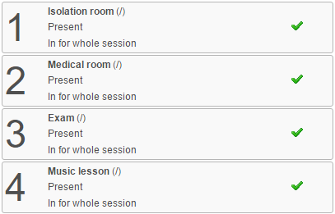

A list of the existing custom codes will be shown. You can click on an existing code to edit it, or click the Add button on the top toolbar to create a new code.

You will need to choose a code (a list of available codes will be presented to you) as well as a description (what the code is used for) and the actual attendance code it is linked to (usually present).

