Creating a new Seating Plan

# Prerequisite Knowledge

You should already know how to access registers. This is covered in the **Take a Register** training guide. You may also need to change user permissions. This is covered in the **Managing Permissions** training guide.

# Creating a Seating Plan

Each room can have multiple seating plan layouts. Each layout is the location of the tables and chairs in the room. Each class that takes place in this room can assign pupils to the seats in the room and access the various features in the seating plan. This guide only covers the process of creating the seating plan layout (placing tables and chairs). See the **Using Seating Plans** training guide for information about assigning pupils and other seating plan features.

Choose the room for which you want to create a seating plan, then open a register that takes place in that room. Once you have opened the register, click the **Seating** button at the top left of the page.

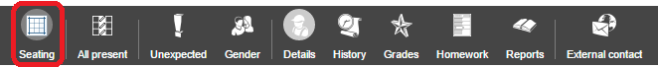

This will open the seating plan for the room. Next click the **Edit** button on the top toolbar.

*If you cannot see the edit button, you need to turn on the* ***User can edit seating plan layouts created in PARS Connect*** *permission from the* ***Attendance*** *section of permissions.*

Click the **Auto Layout** button from the top toolbar. This will open a window in the middle of the page. In this window, click on the **Chair** button at the top left.

The grid of squares represents the classroom. Click on a square to place a chair in the room. You should work from the top left of the window outwards. You can click and drag to select multiple slots at once.

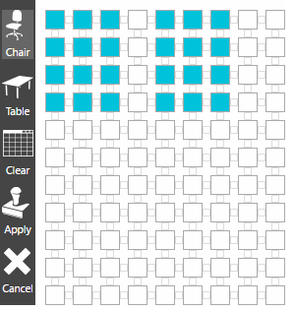

If you accidentally place a chair in the wrong location, click on it again to remove it. You can also place tables but this is optional and tables do not add any functionality to the seating plan. Many schools use a single desk to denote the position of the teacher.

Once you are happy with the layout of the room, click the **Apply** button on the left of the **Auto Layout** window. The window will close and the chairs will appear on the page. Chairs can be individually repositioned by dragging and dropping them. Additional chairs can be added by clicking the **Chair** button on the top toolbar.

When you are happy with the seating plan, click the **Save** button on the top toolbar. You will be prompted to **Save** or **Overwrite**. Choosing overwrite will overwrite the existing layout for the room, choosing Save will create a new, alternate layout for the room.

The seating plan layout is now saved. Any class that takes place in this room will now be able to use this layout.

