Chasing missing registers

The missing registers page is used to chase missing registers by sending messages directly to the teachers. The page is accessed via:
Main menu > Attendance > Missing registers

Click the Select staff button at the top left of the page and a window will open. At the top left of the window click on Staff then Teaching staff.
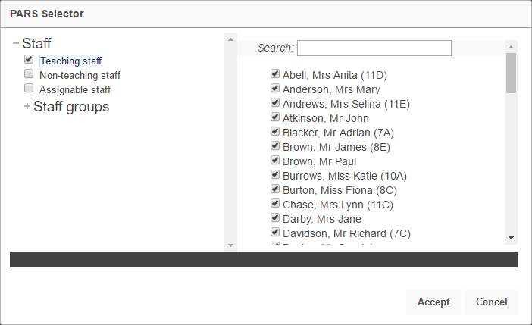

The start and end date used can be seen on the top toolbar and will default to today’s date. Either of the dates can be changed by clicking on the appropriate button.

Click the Refresh button once you are happy with the date range. PARS will display all of the missing registers for the day.
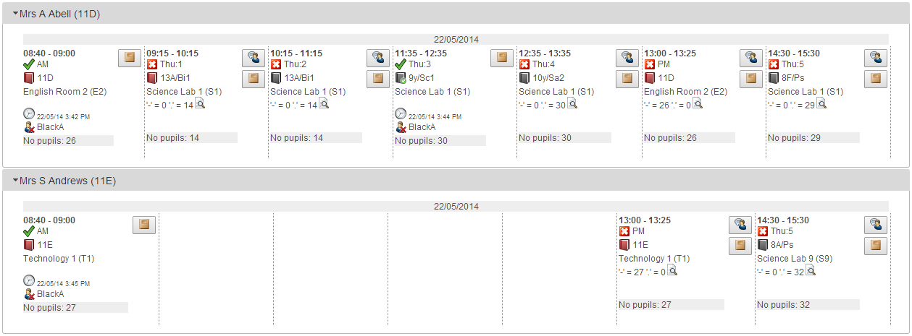

You may see some registers that have been completed. If this is the case you need to apply a filter to the page. Click the Filter button and select the top two options in the window that appears. If you have any mapped session registers (e.g. the PM mark is taken from the register for period 4) then you should also select the Hide mapped session registers option. Click OK when done.
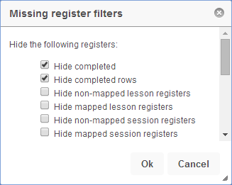

You will now only see registers that are missing. Clicking the Send notices button on the top toolbar will send a notice to every teacher who has a missing register for a lesson that has already finished. PARS will not send notices for lessons that have not yet finished.

PARS will only send a notice about a register once. If you click the Send notices button several times during a day, PARS will only send notices about registers if it has not sent a notice about that register earlier in the day.

The default message used for missing registers is:
You have missing marks for the following groups: [list of registers]

The default message can be changed by clicking the Edit notice button and typing a new message.

The notice that you send will always appear in the missing registers section of the teacher’s notices. The preferences page in PARS can also be configured to force these notices to be sent as emails.
